OPTIMIZING FLIGHT BOOKING DECISIONS THROUGH MACHINE LEARNING

PRICE PREDICTIONS

SUBMITTED BY,

Team leader: a.sandhiya

Team mates: m.sangeetha

r.sangeethapriya

s.snega

**INTRODUCTION**

OVERVIEW

* People who work frequently travel through flight will have better knowledge on best discount and right time to buy the ticket.
* For the business purpose many airline companies

change prices according to the seasons or time.

* They will increase the price when people travel more. Estimating the highest prices of the airline data for the route is collected with features such as Duration, Destination, Arrival and Departure.
* Features are taken from chosen dataset and in the price where in the airline price ticket costs vary overtime.
* We have implemented flight price prediction for users by using KNN, decision tree and random forest algorithms.
* Random Forestshow the best accuracy of 80% for predicting the flight price. Also, we have done correlation tests and metrics for the statistical analysis.

***PURPOSE***

* Airline tickets are important document that confirm a passenger has a sent on a flight.
* The ticket includes important information about the passenger and the flight that they will take.
* The ticket is exchanged for a boarding pass during the check-in process, and this gives the passengers permission to board the plane.

***PROBLEM DEFINITION & DESIGN THINKING***

***Empathy map***

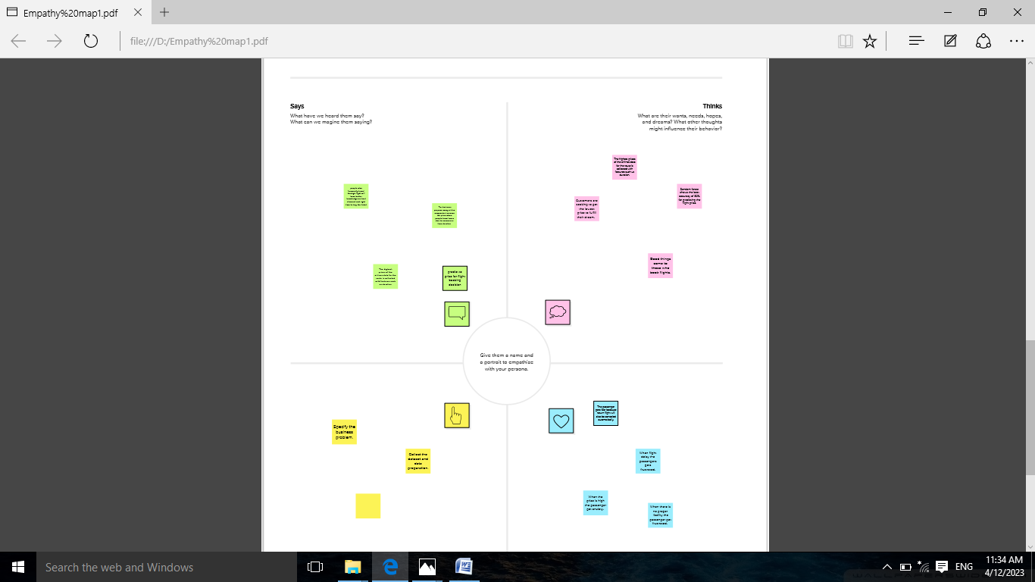

***IDEATION &BRAINSTORMING MAP***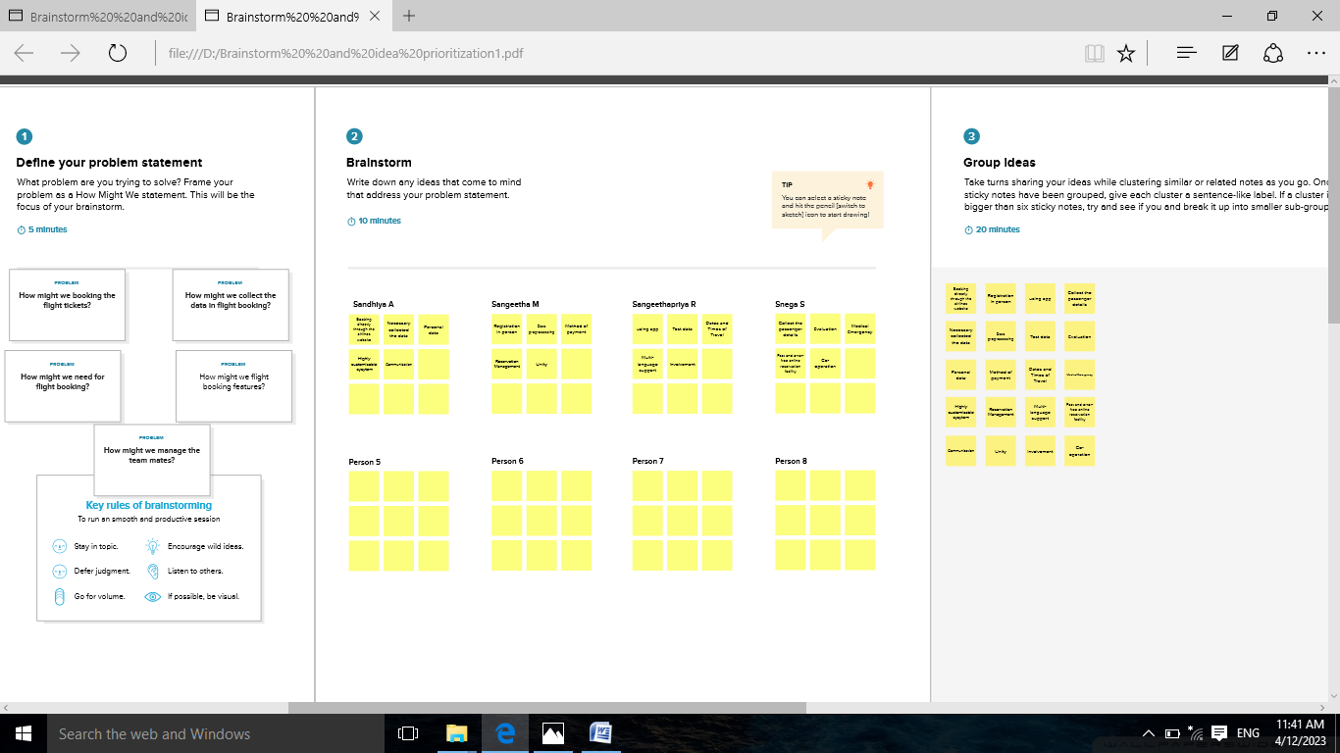

***RESULT***

***FINAL FINDINGS OUTPUT OF THE PROJECT***

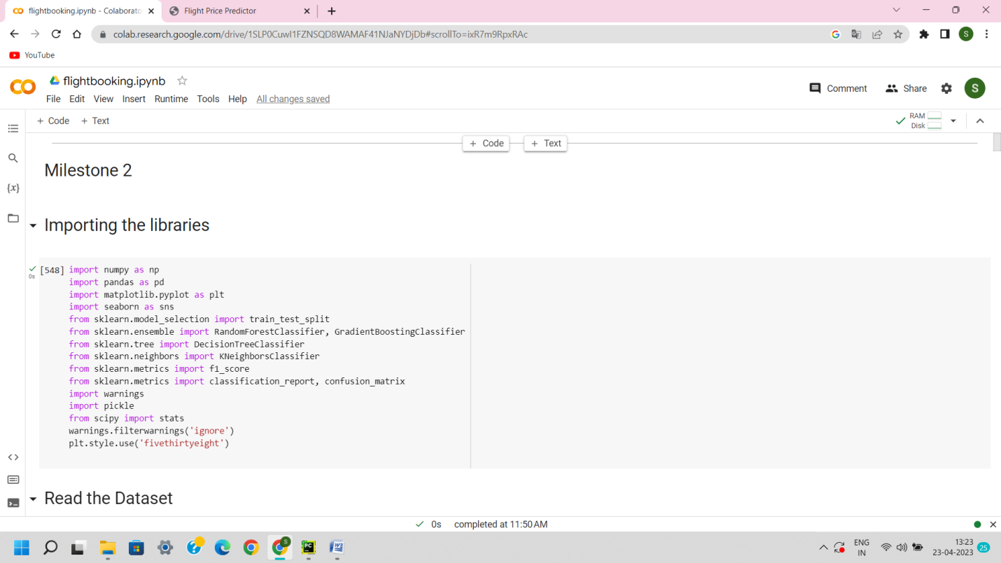

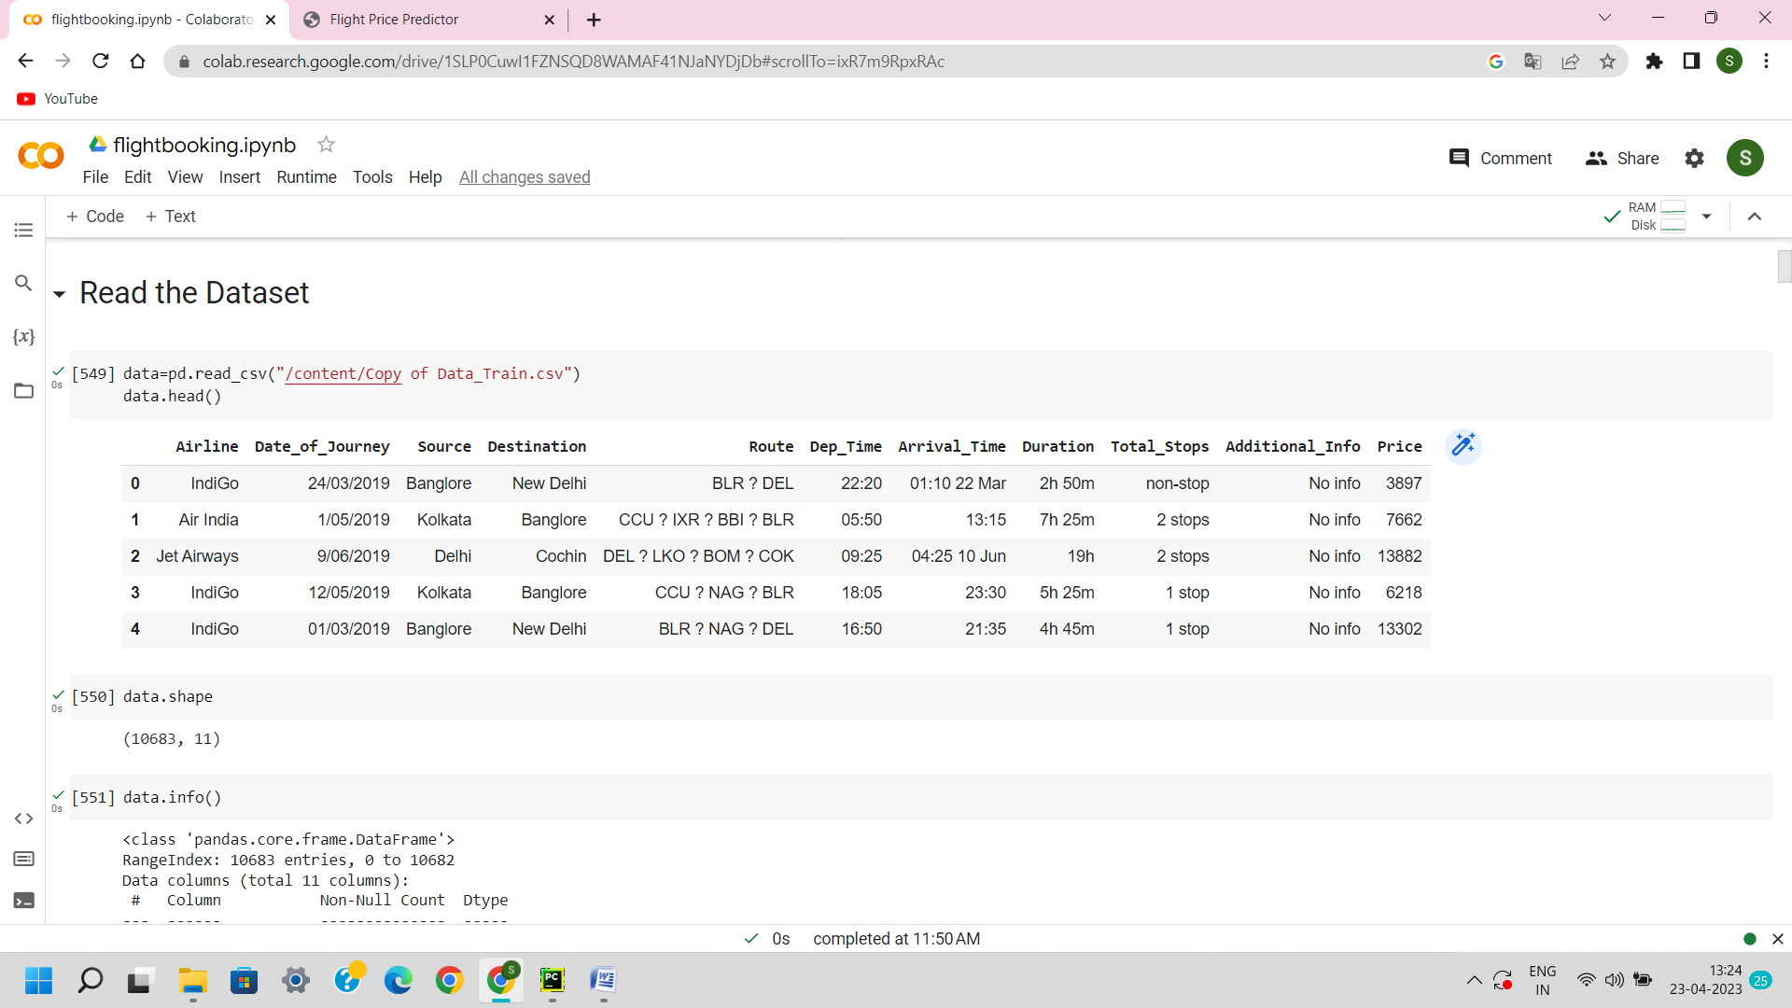

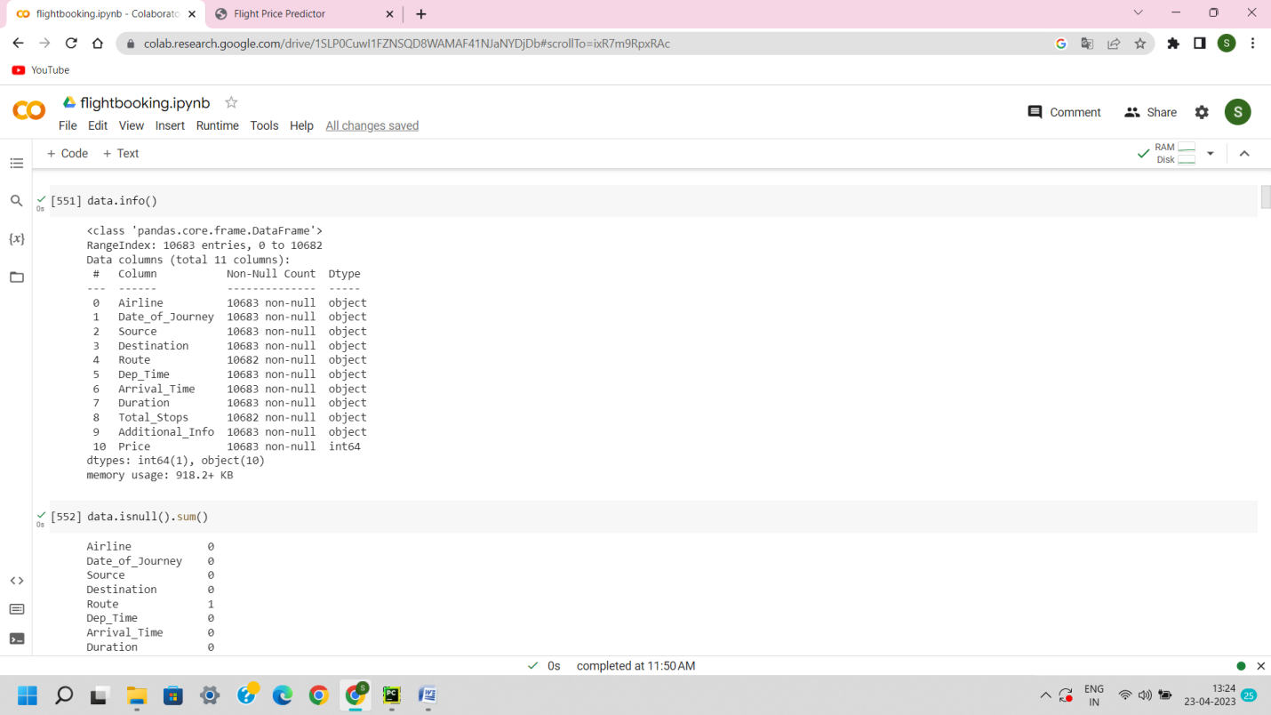

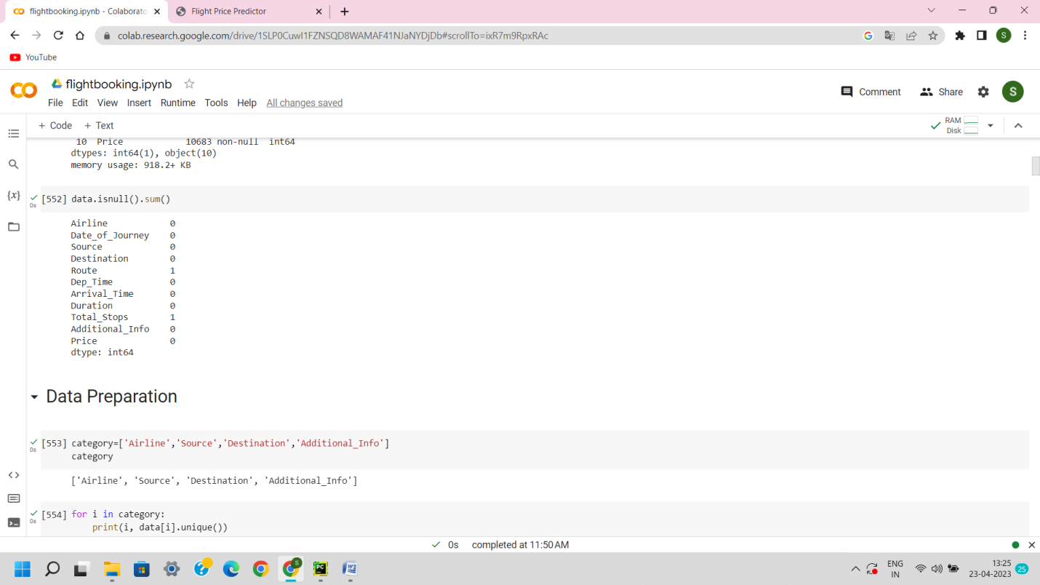

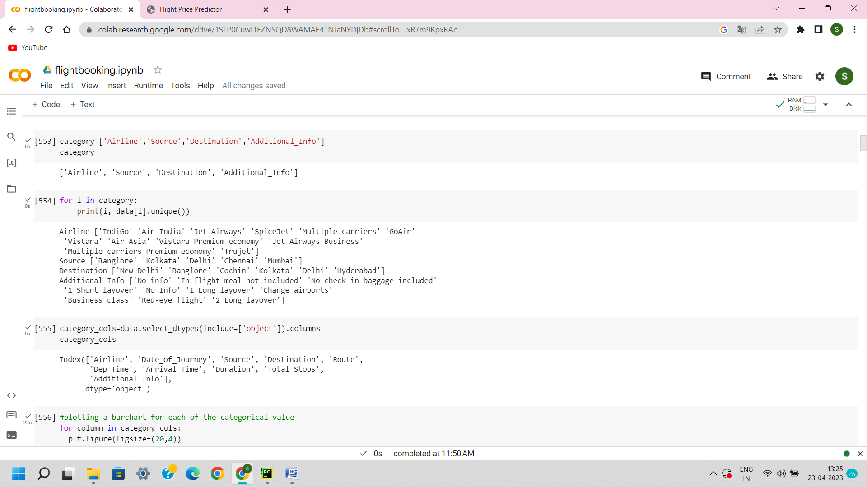

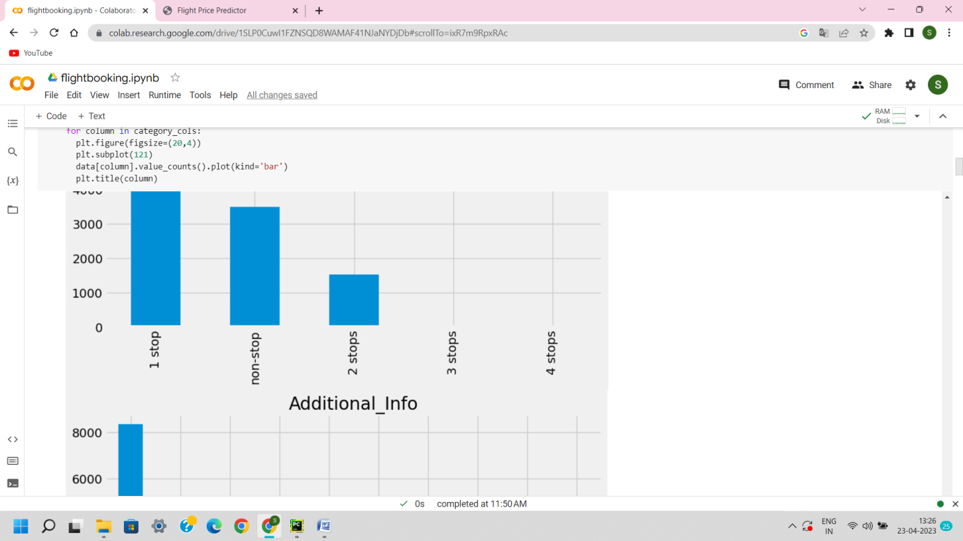

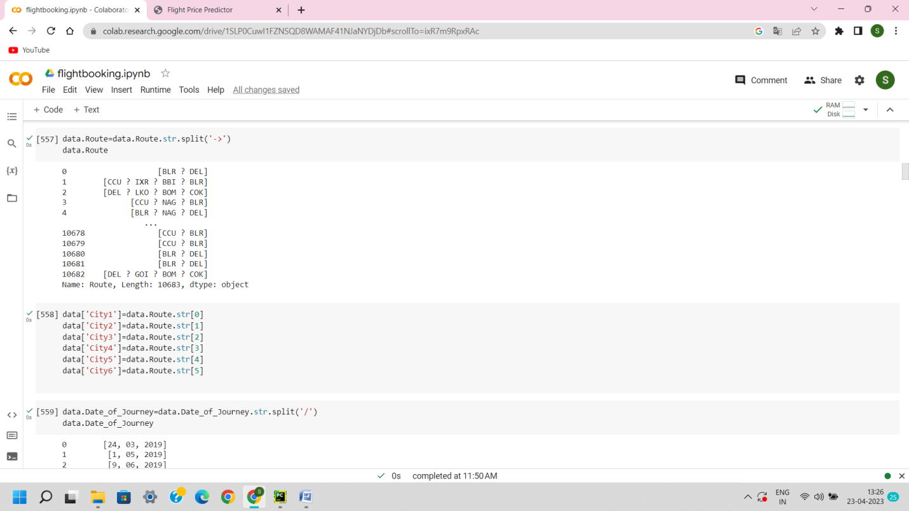

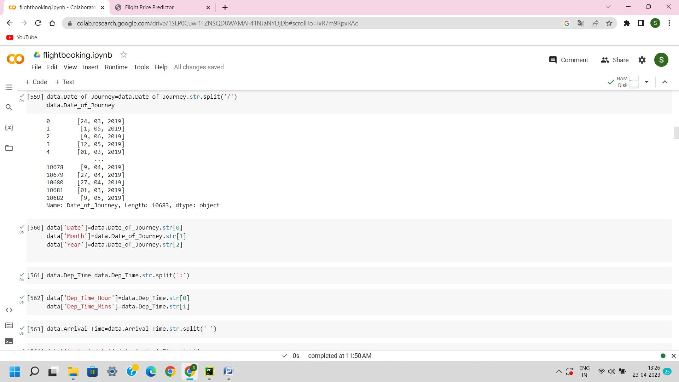

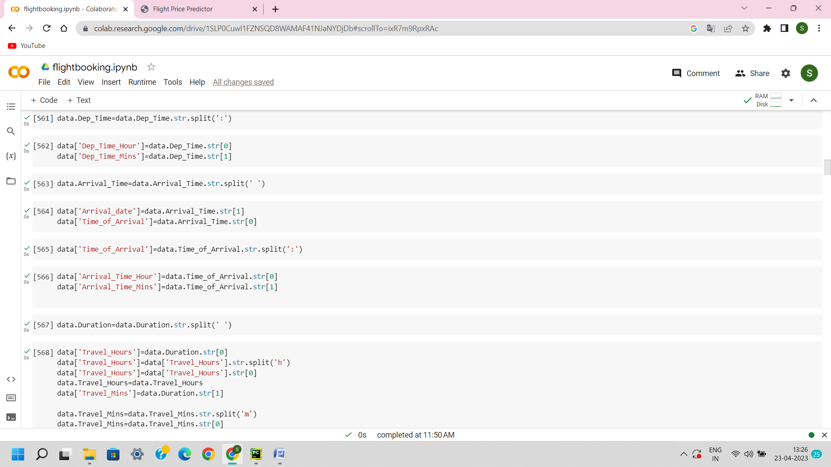

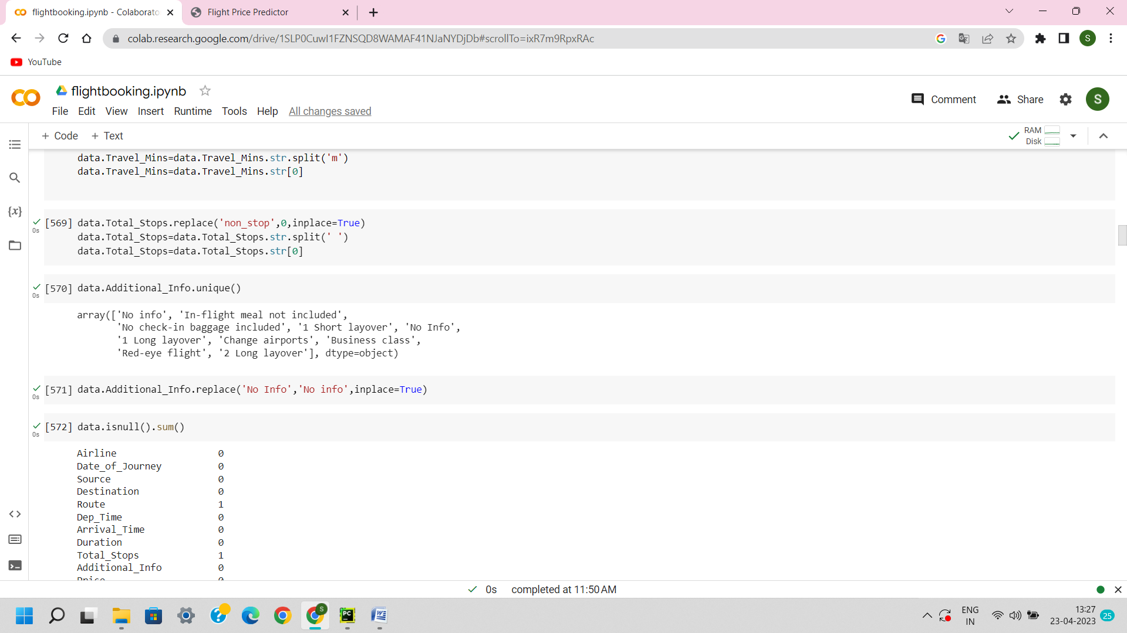

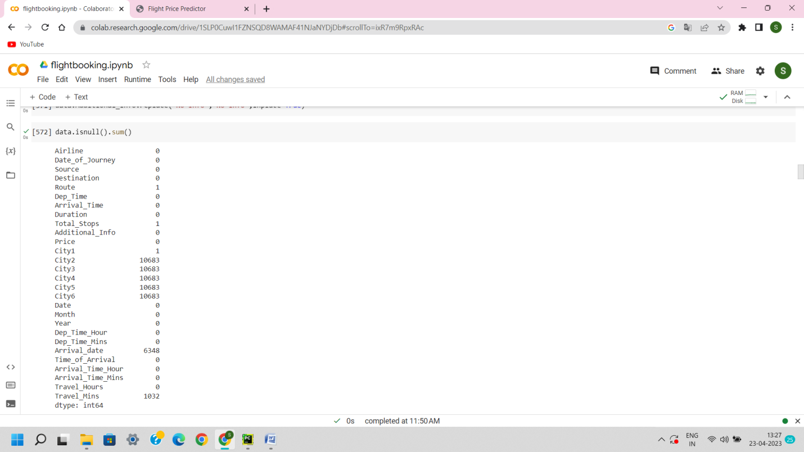

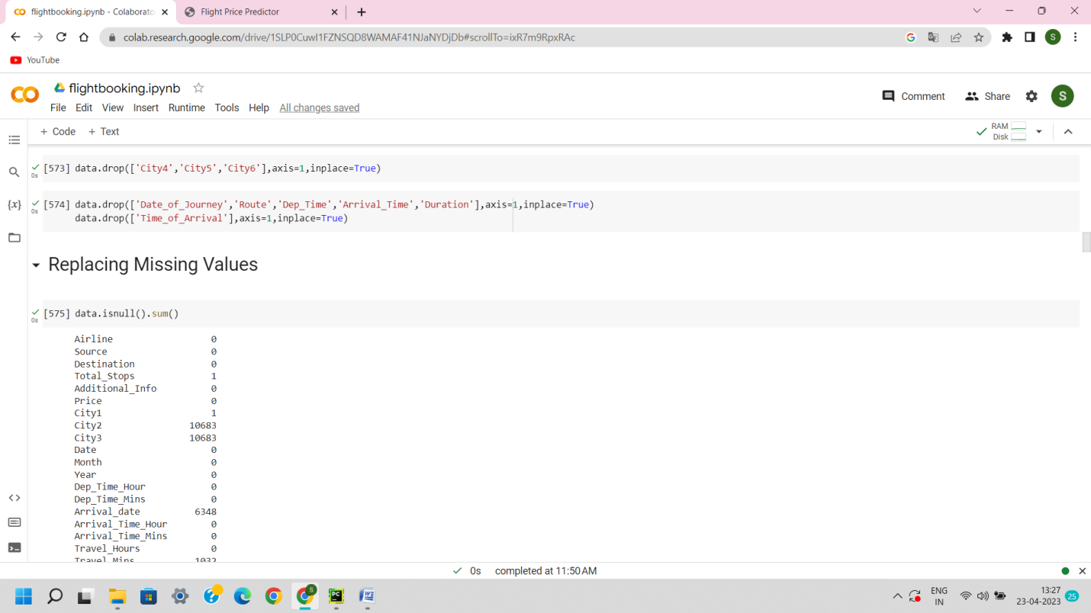

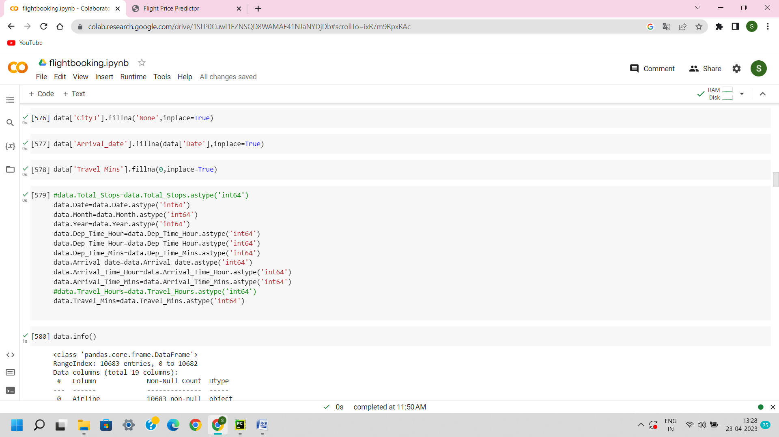

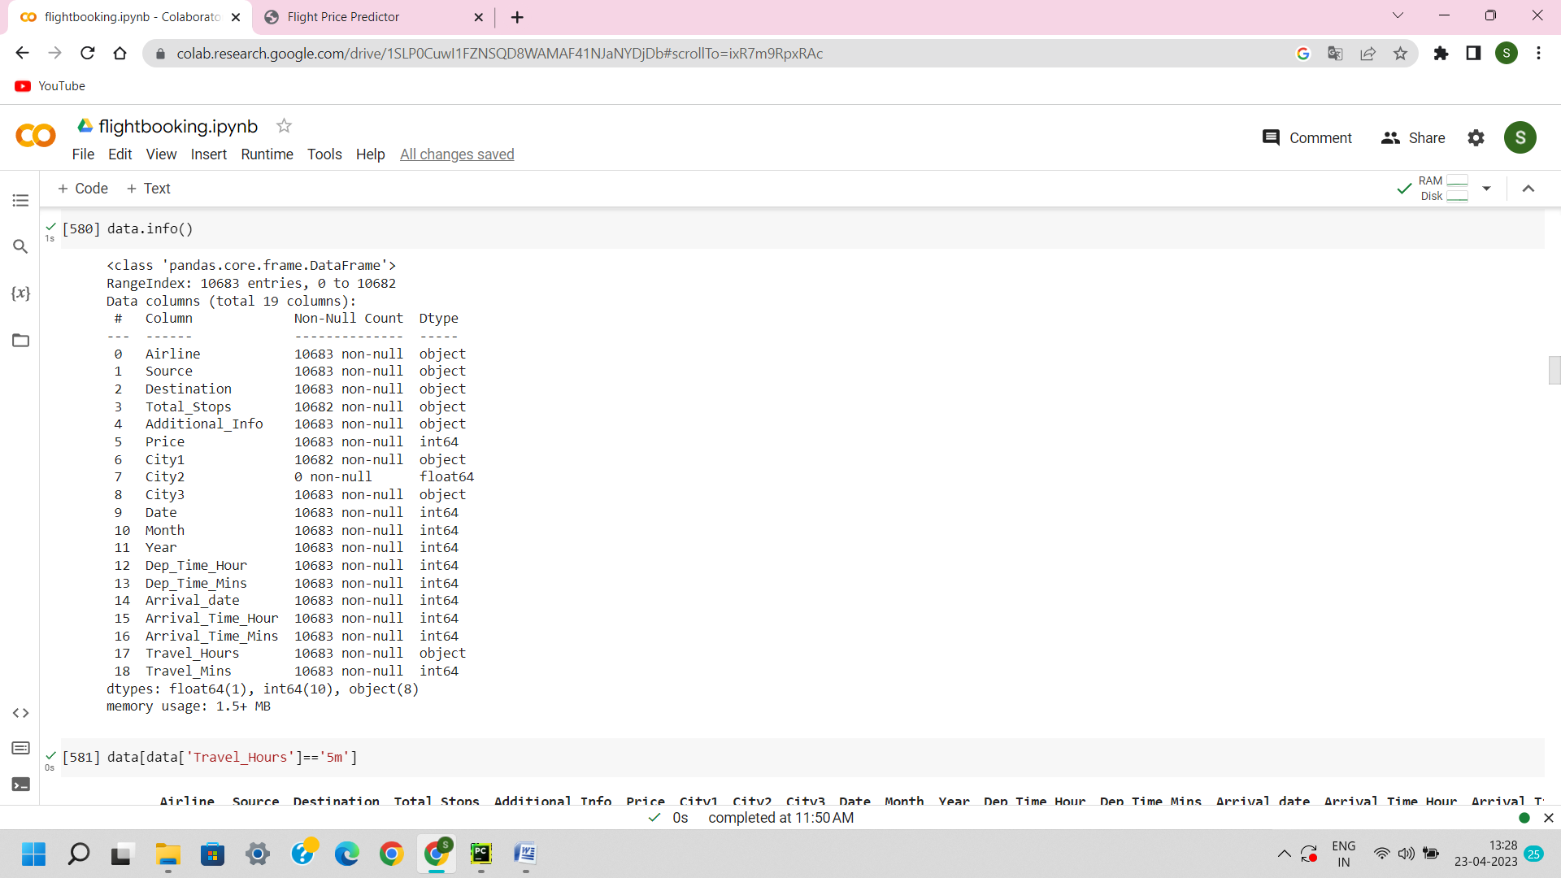

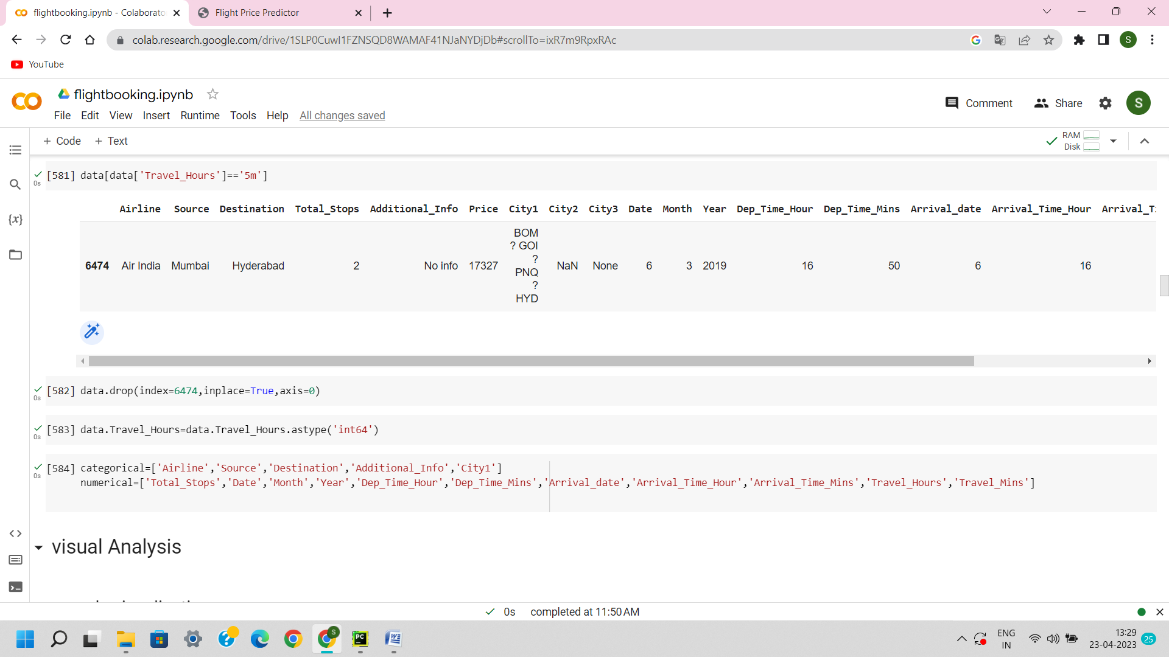

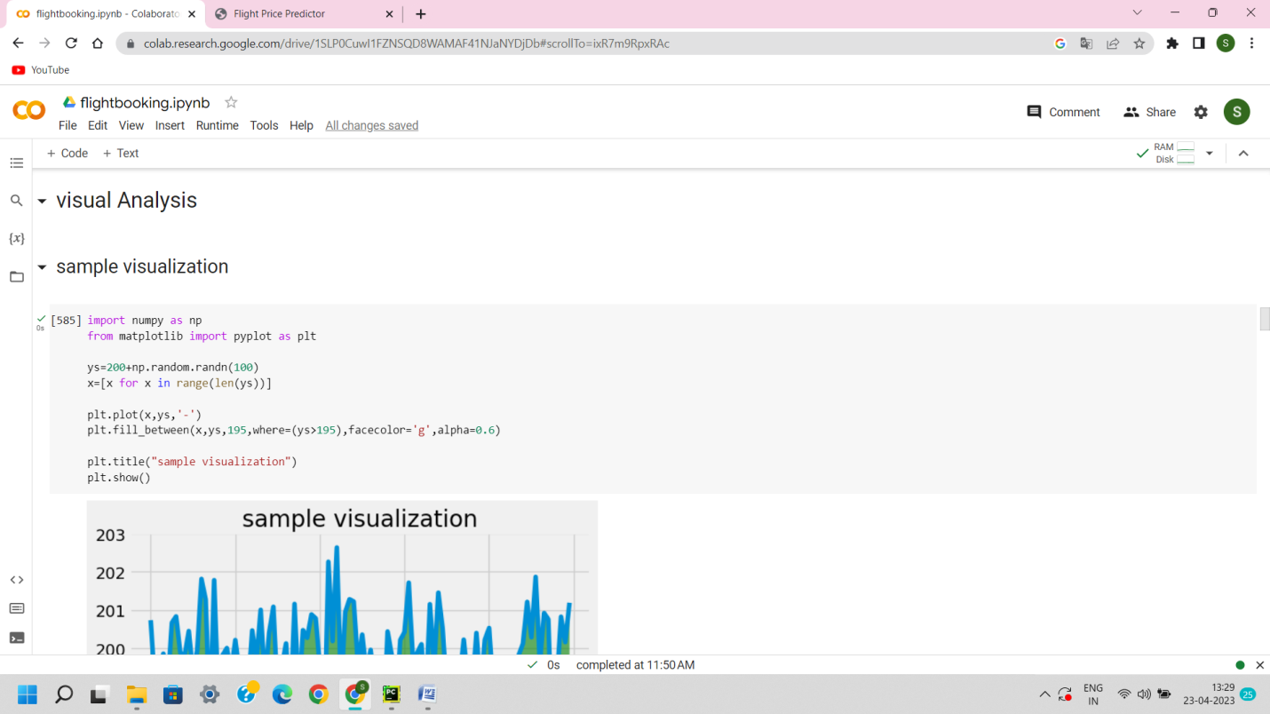

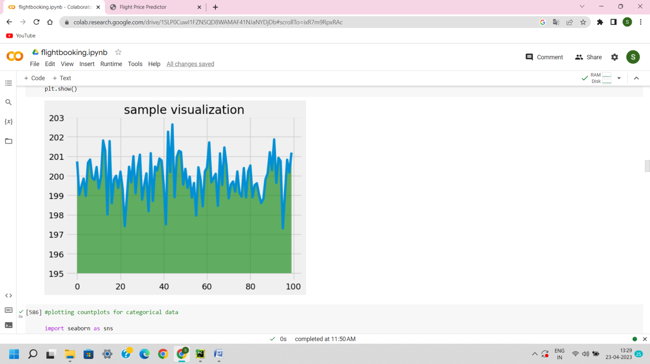

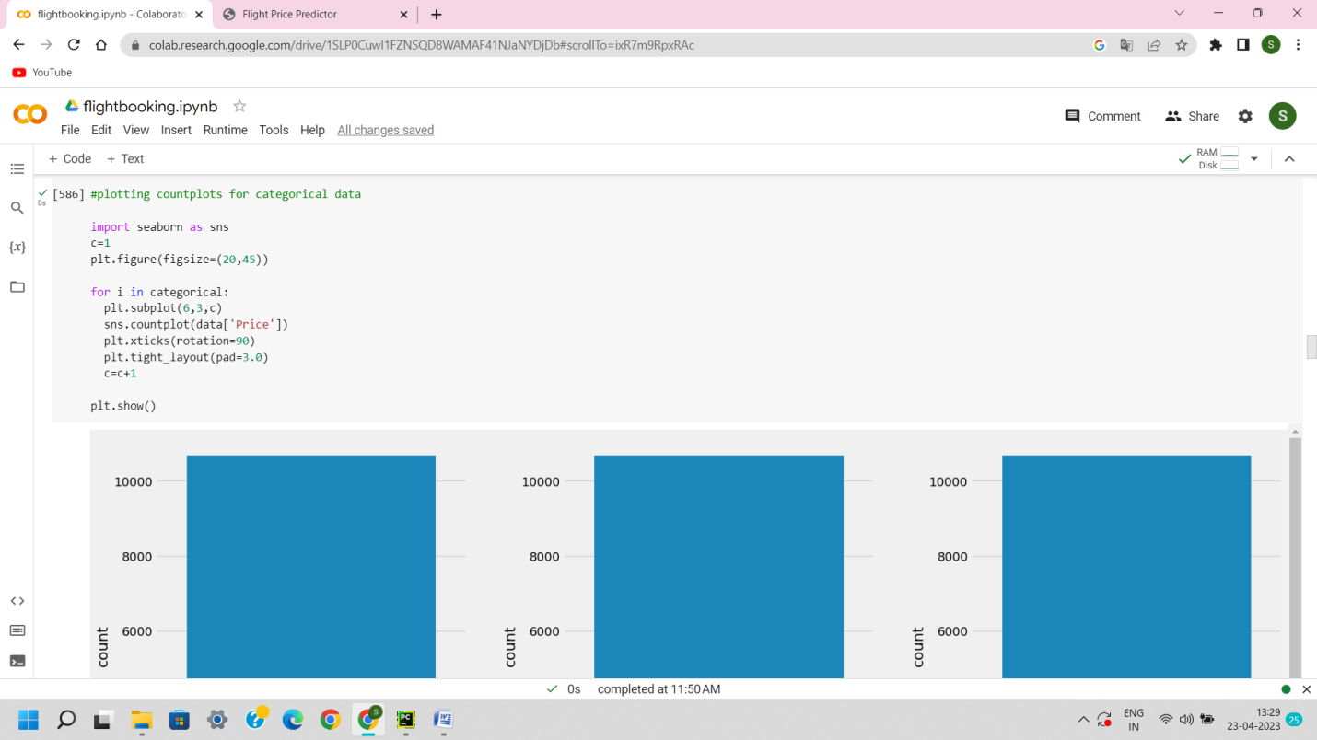

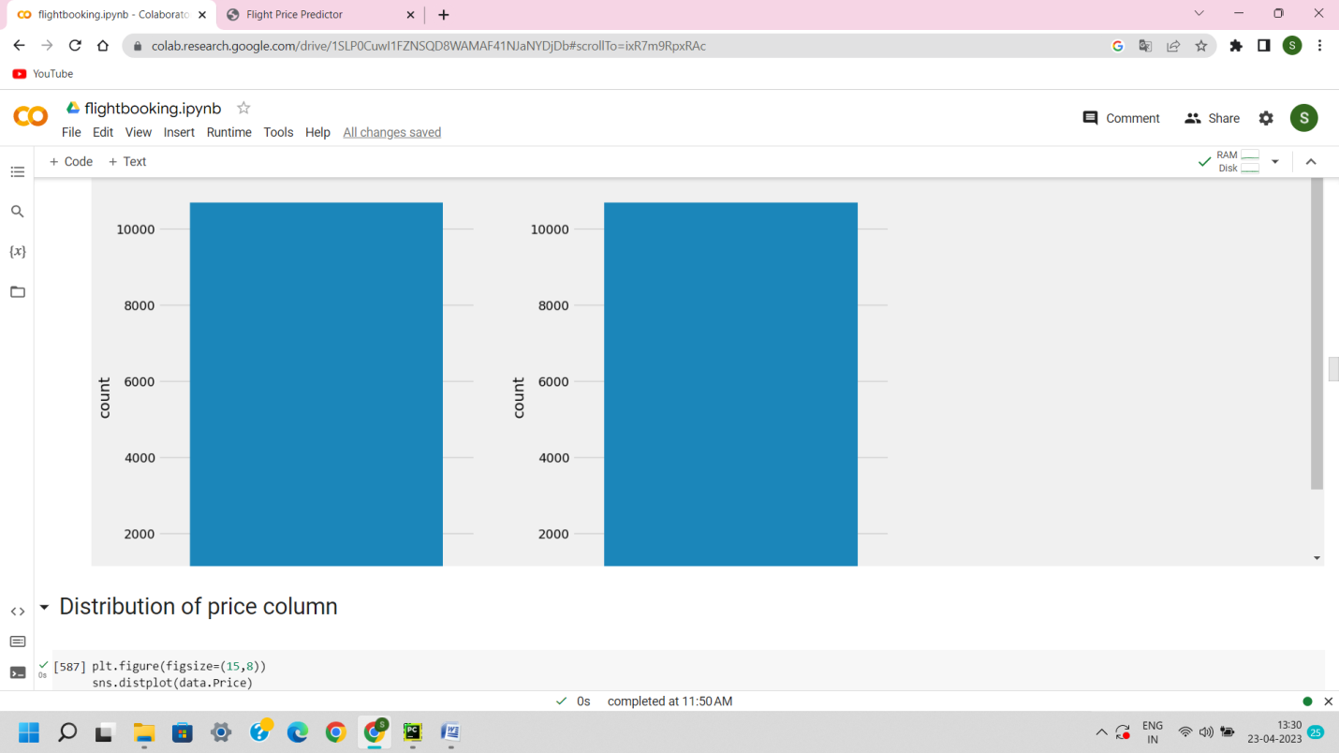

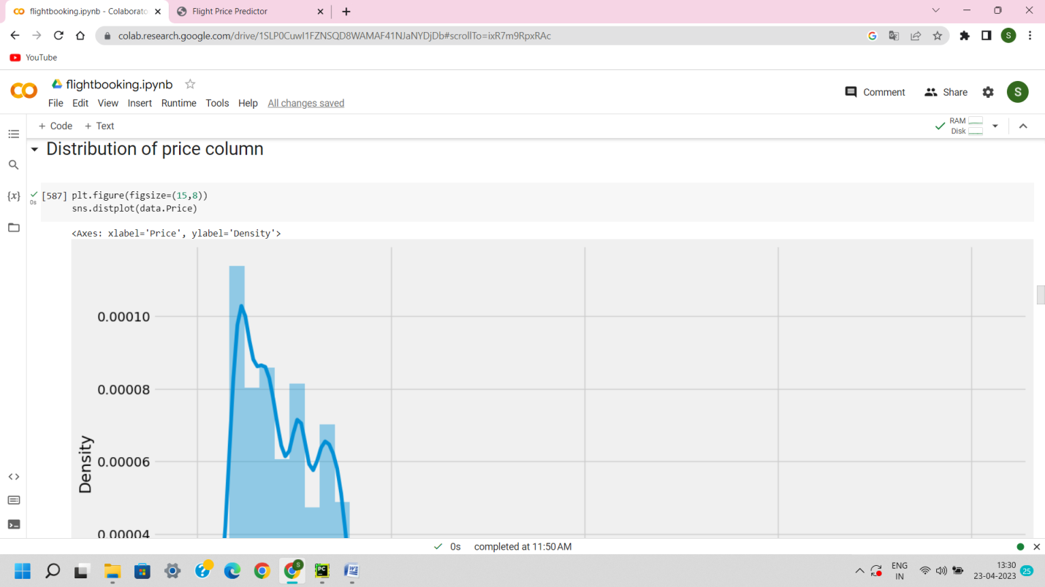

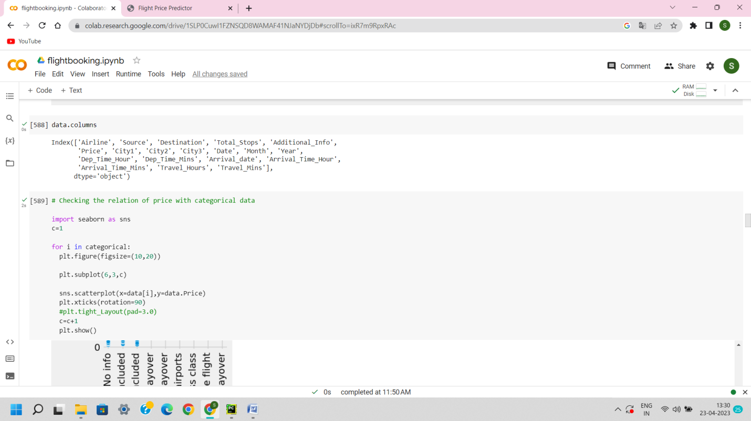

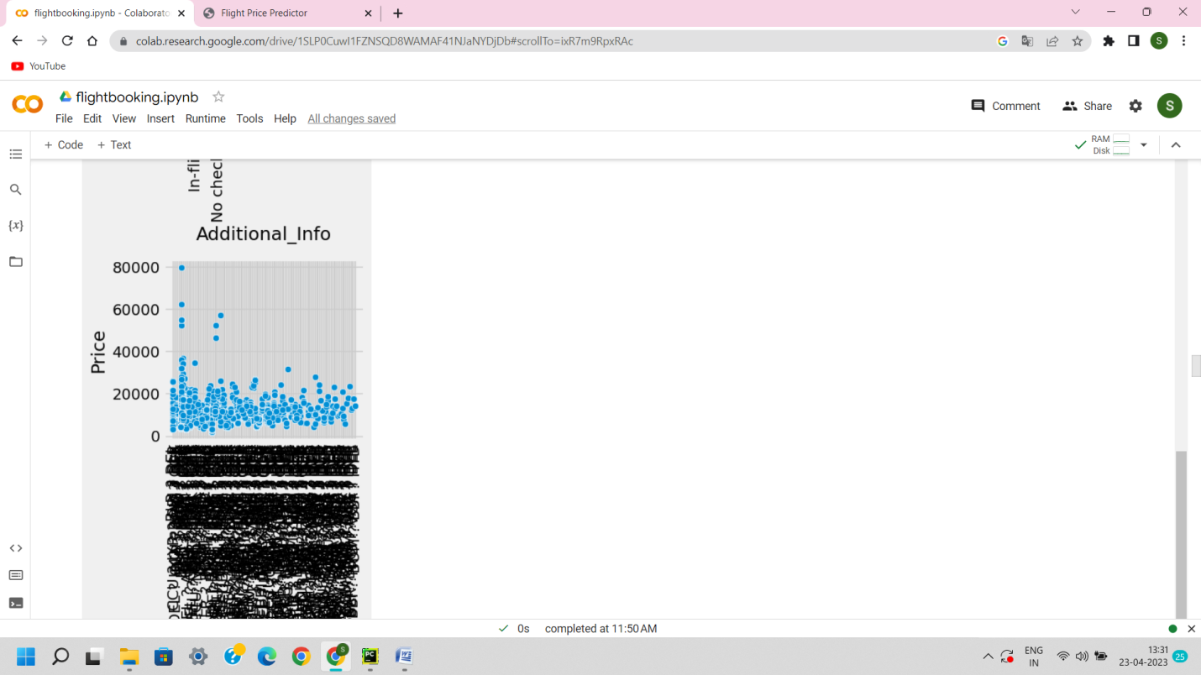

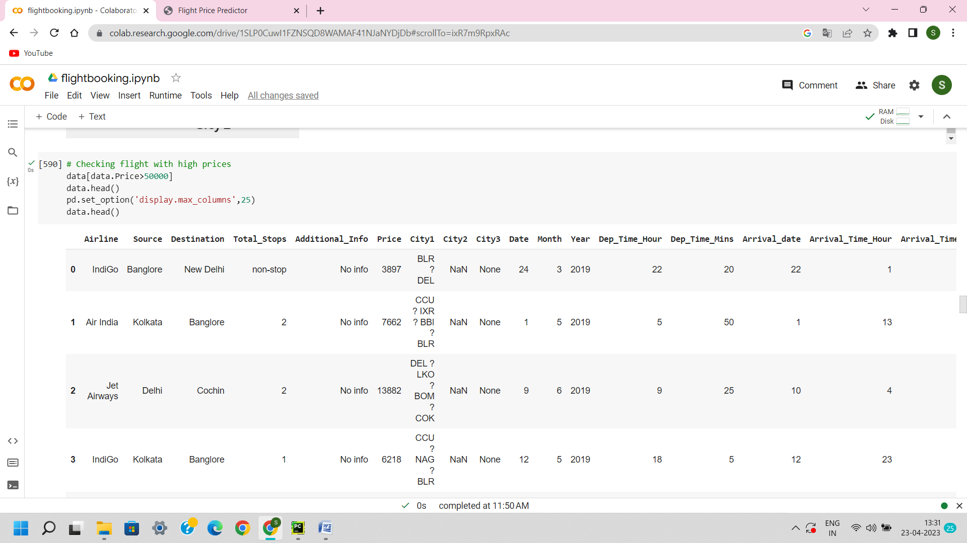

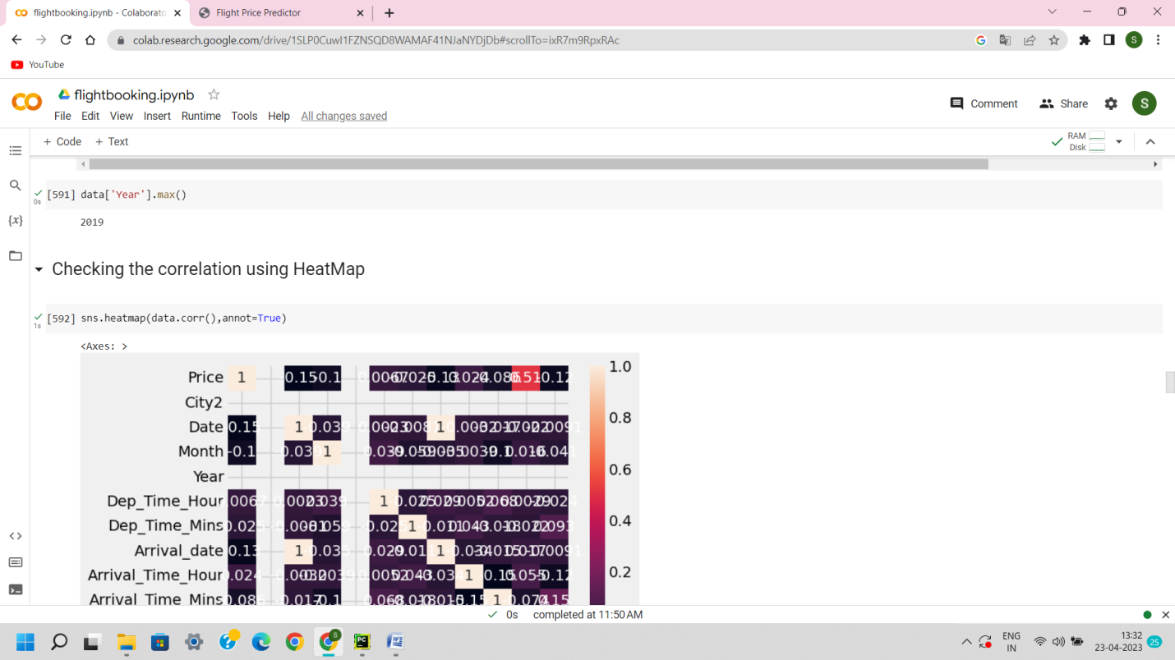

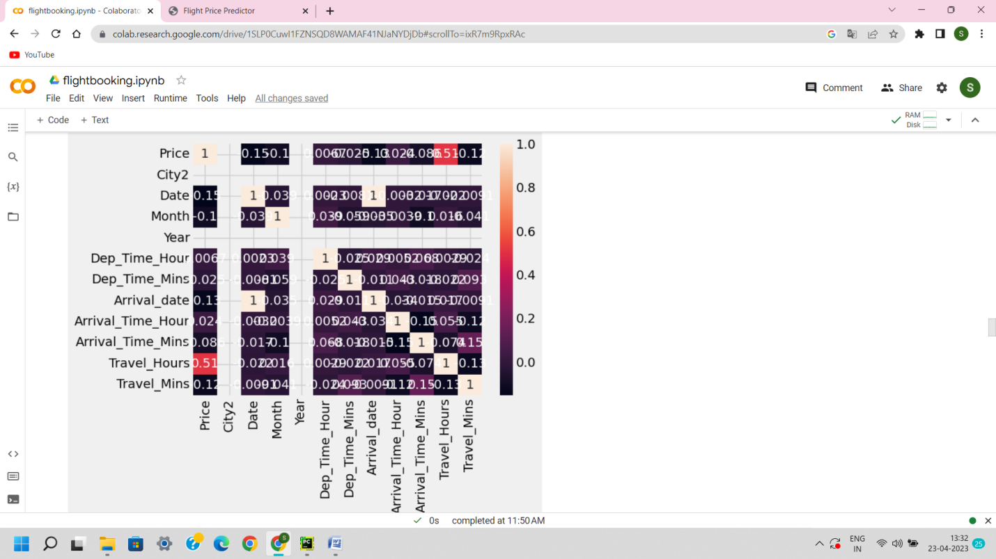

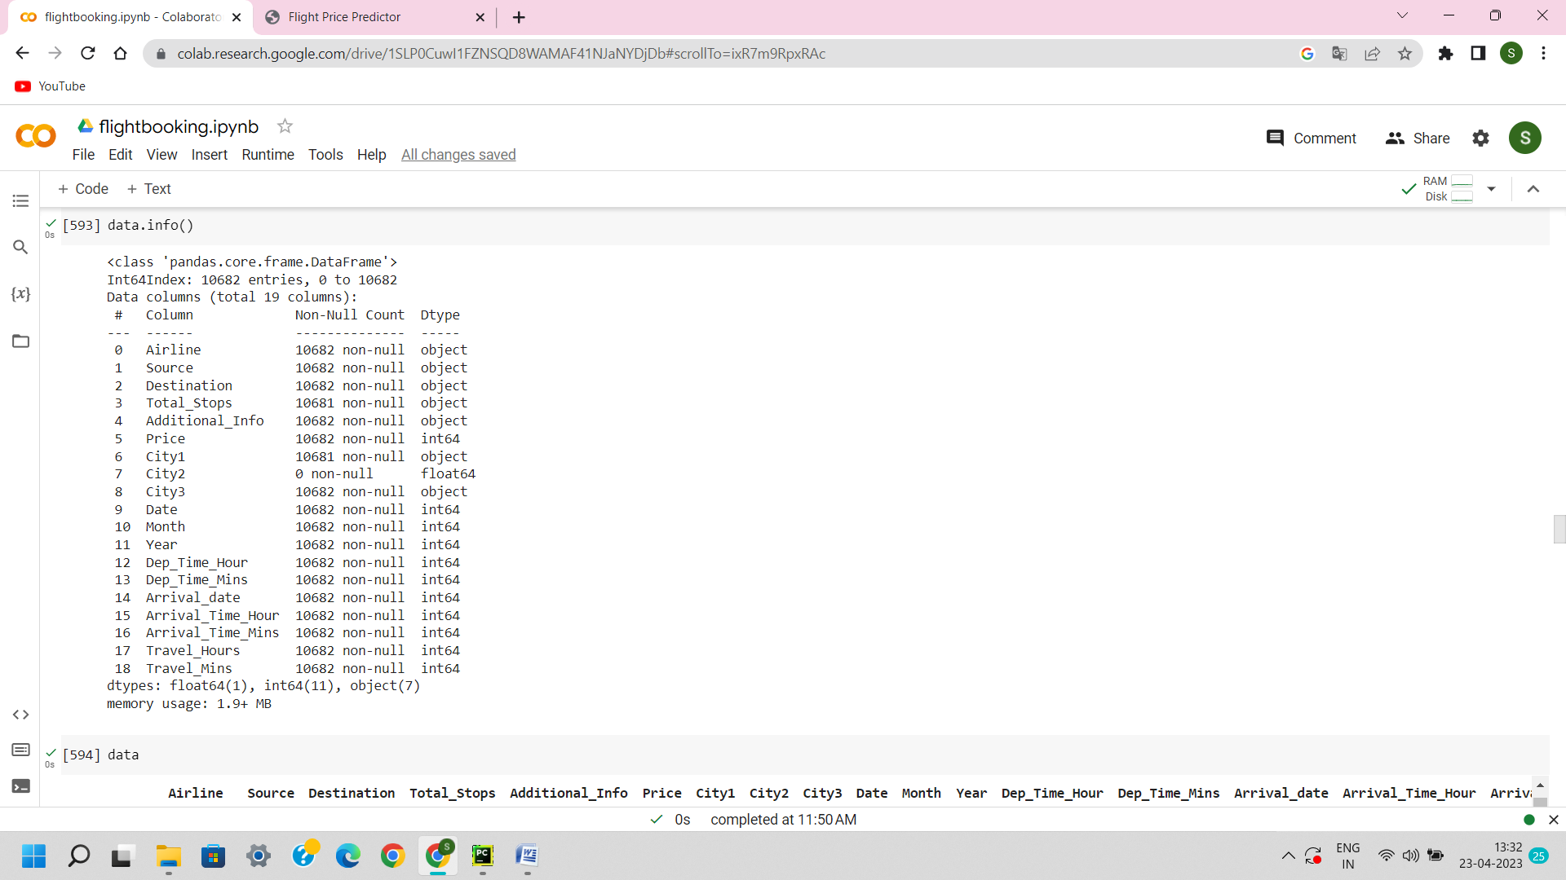

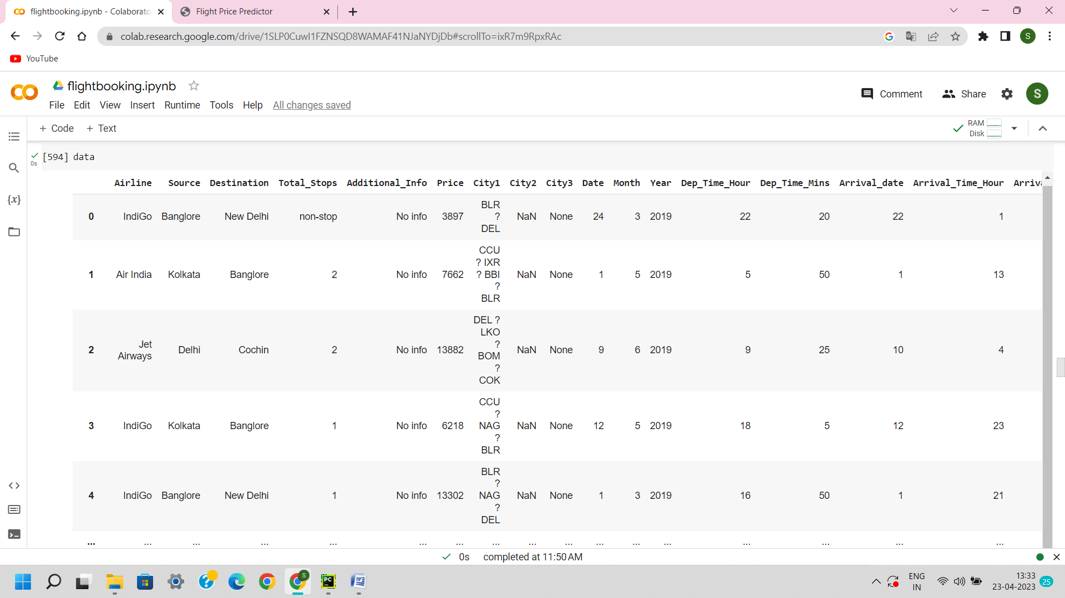

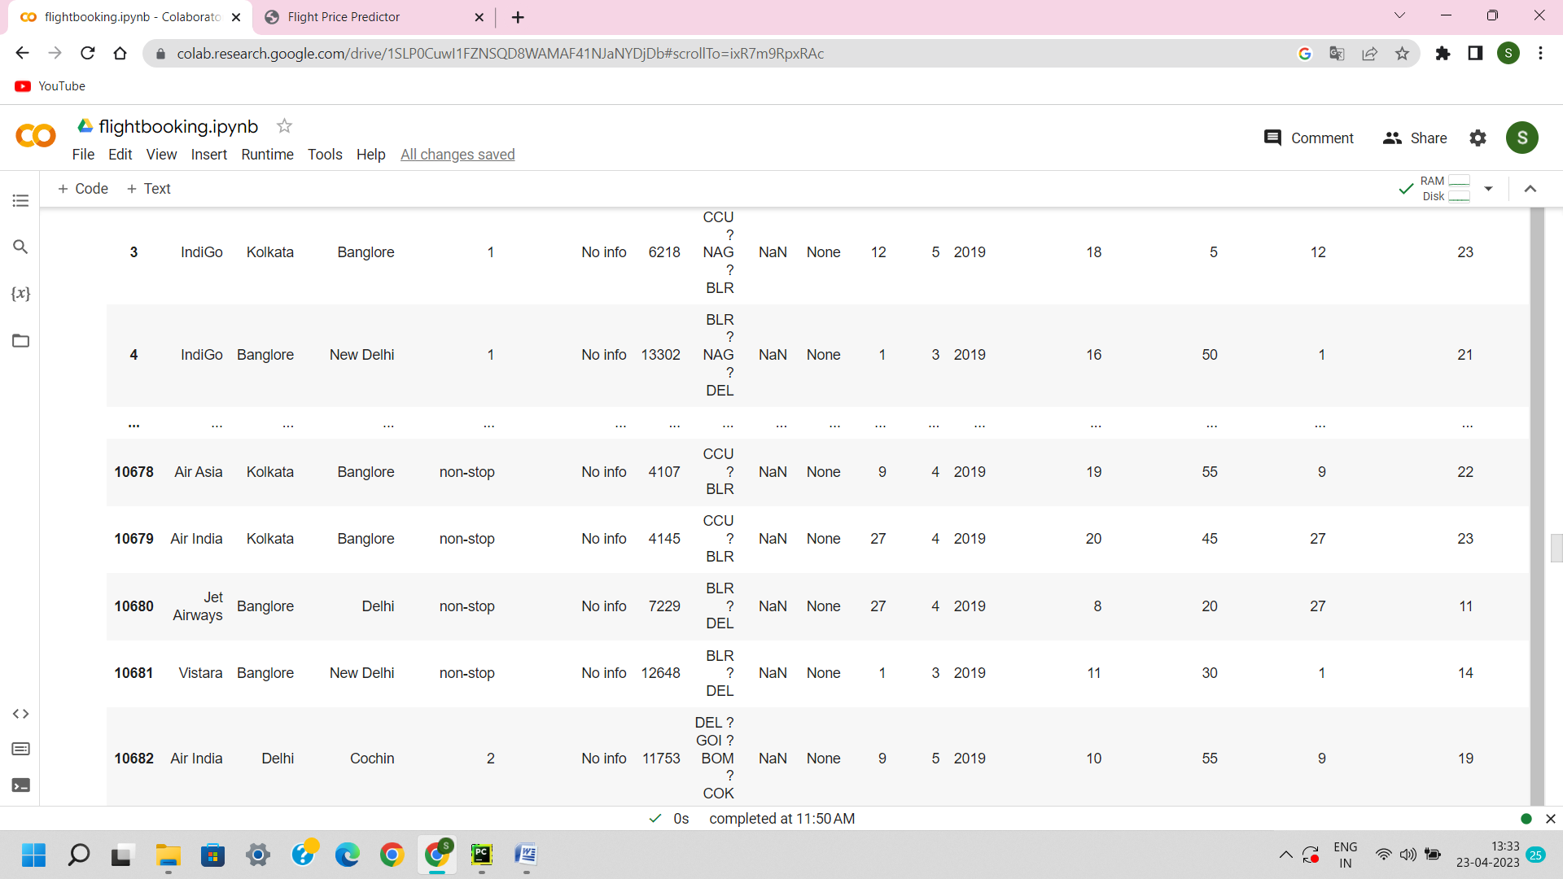

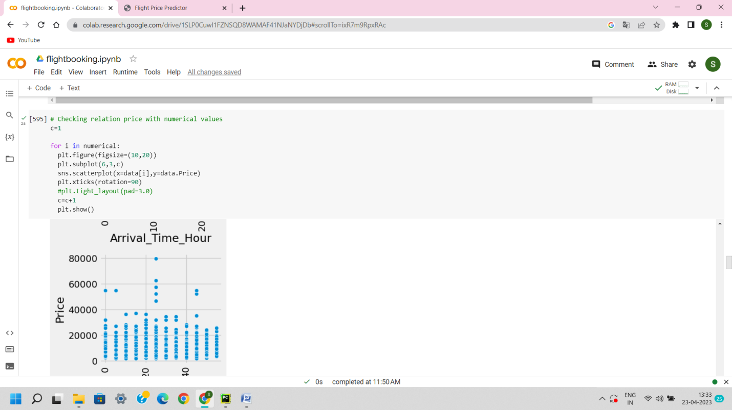

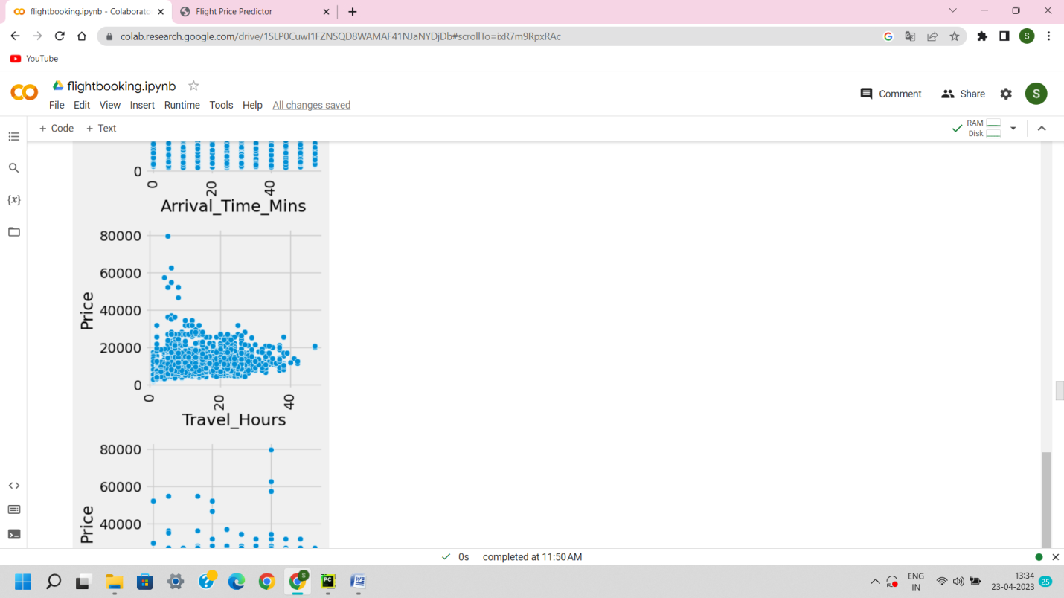

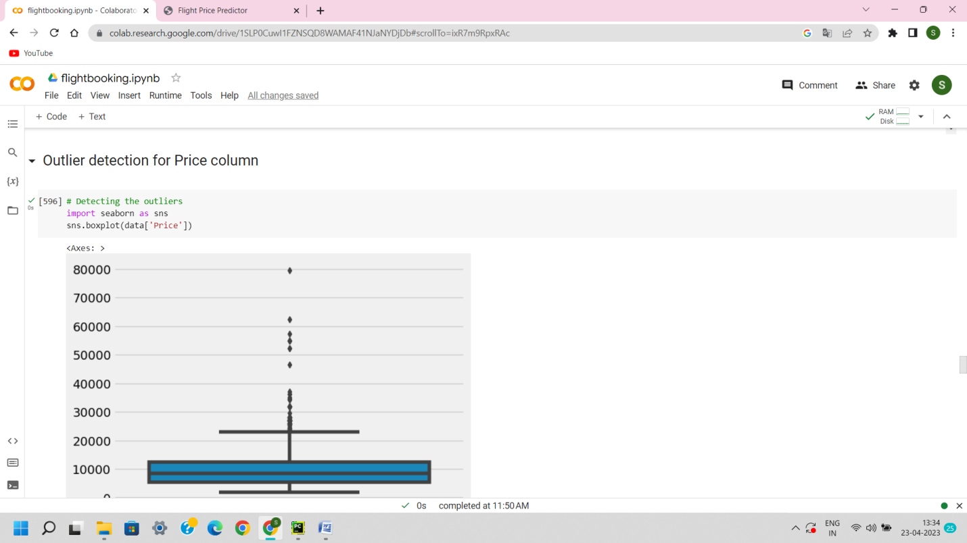

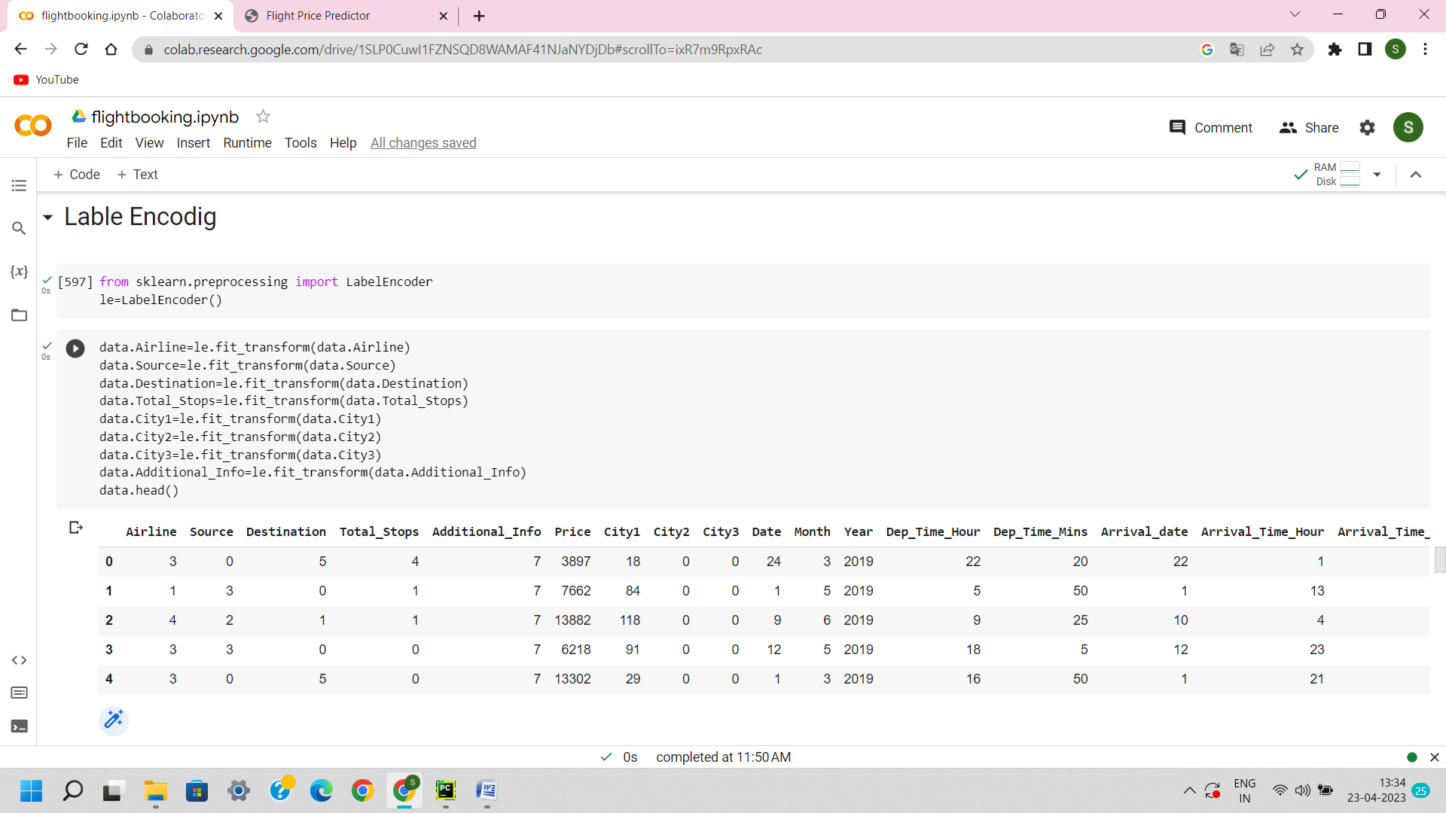

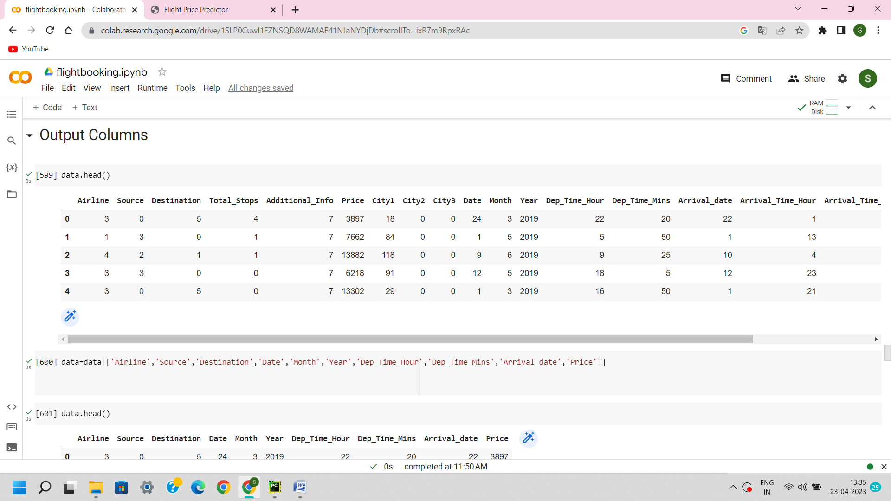

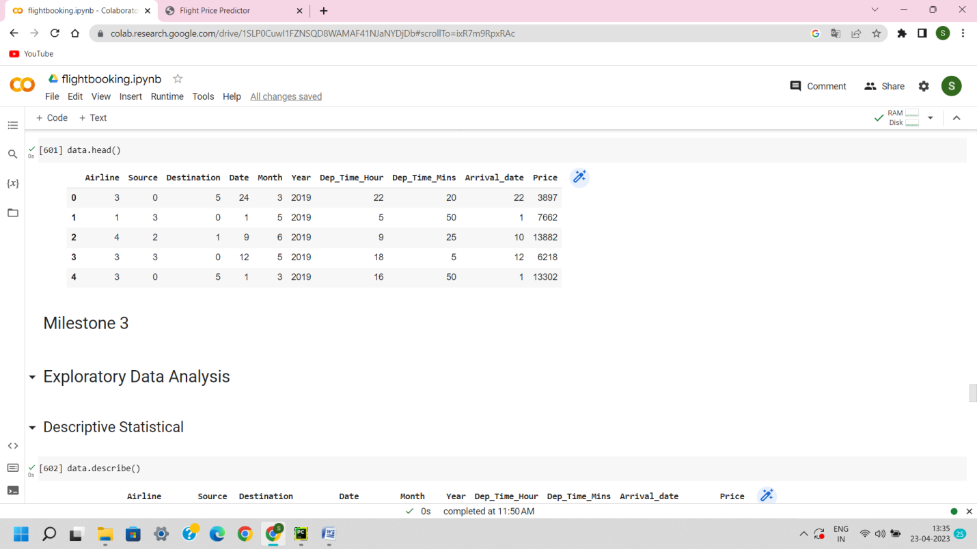

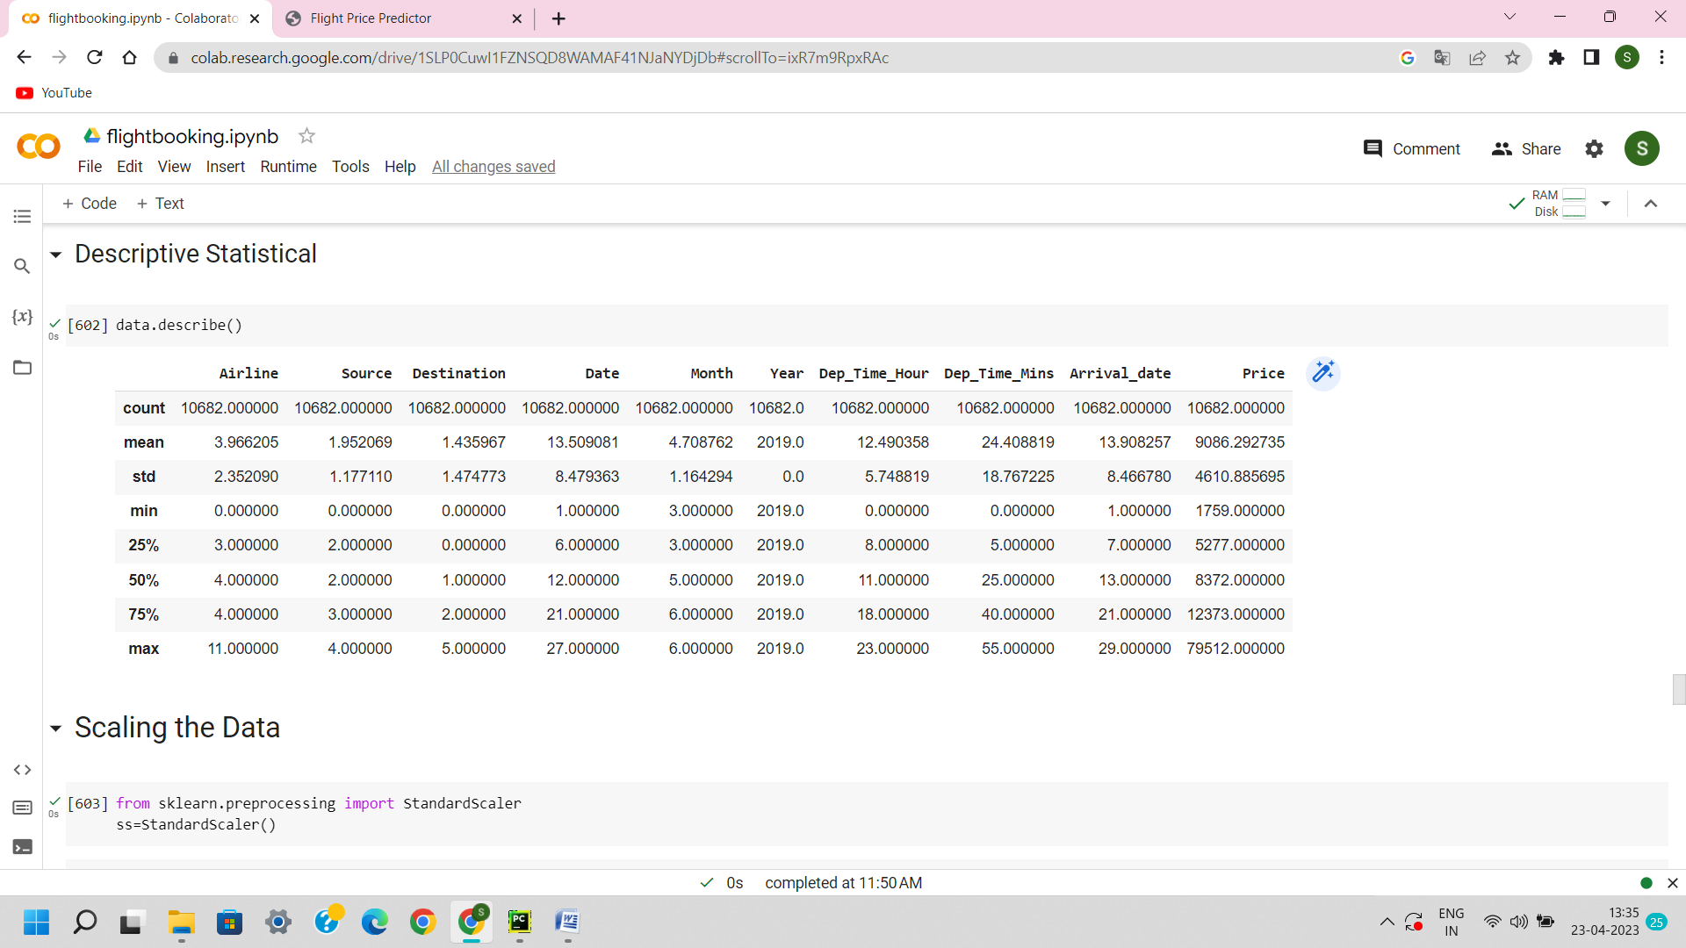

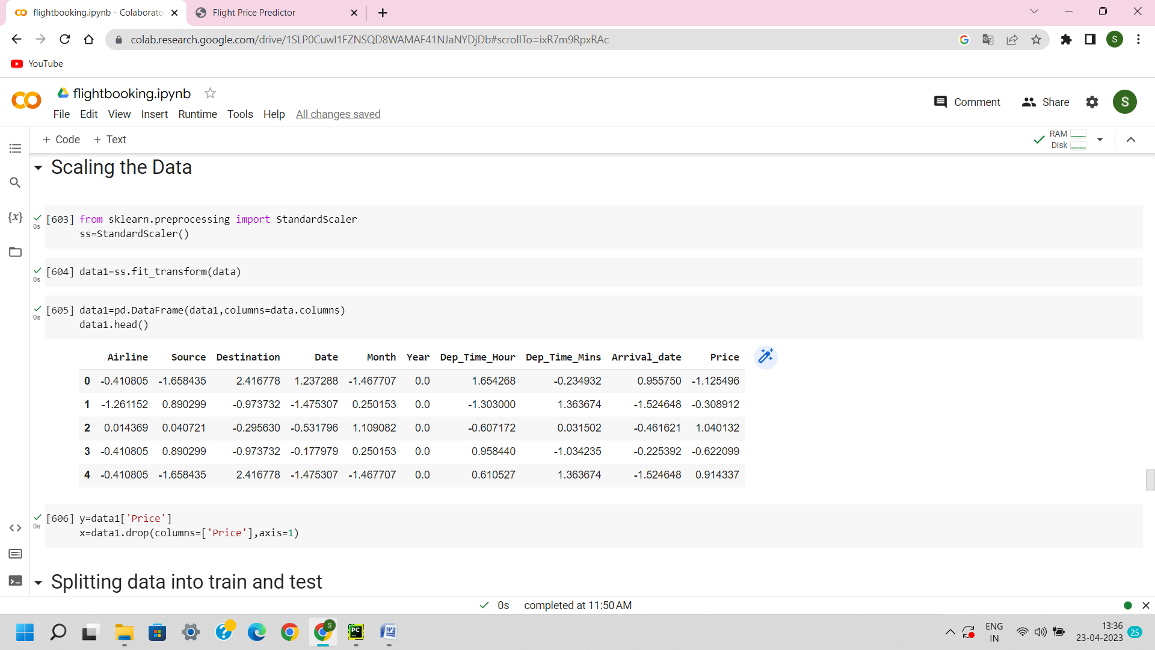

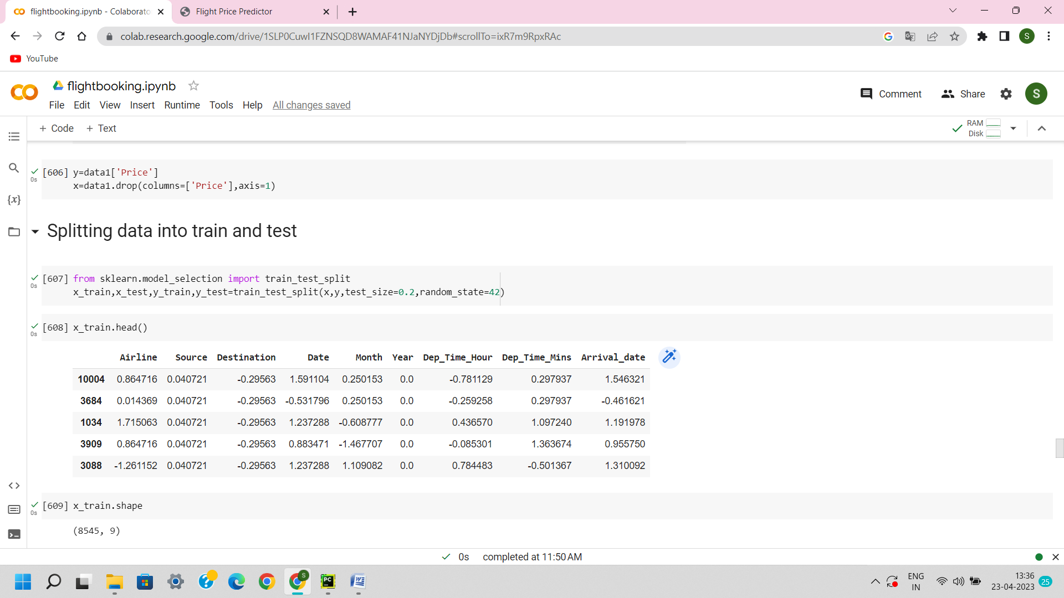

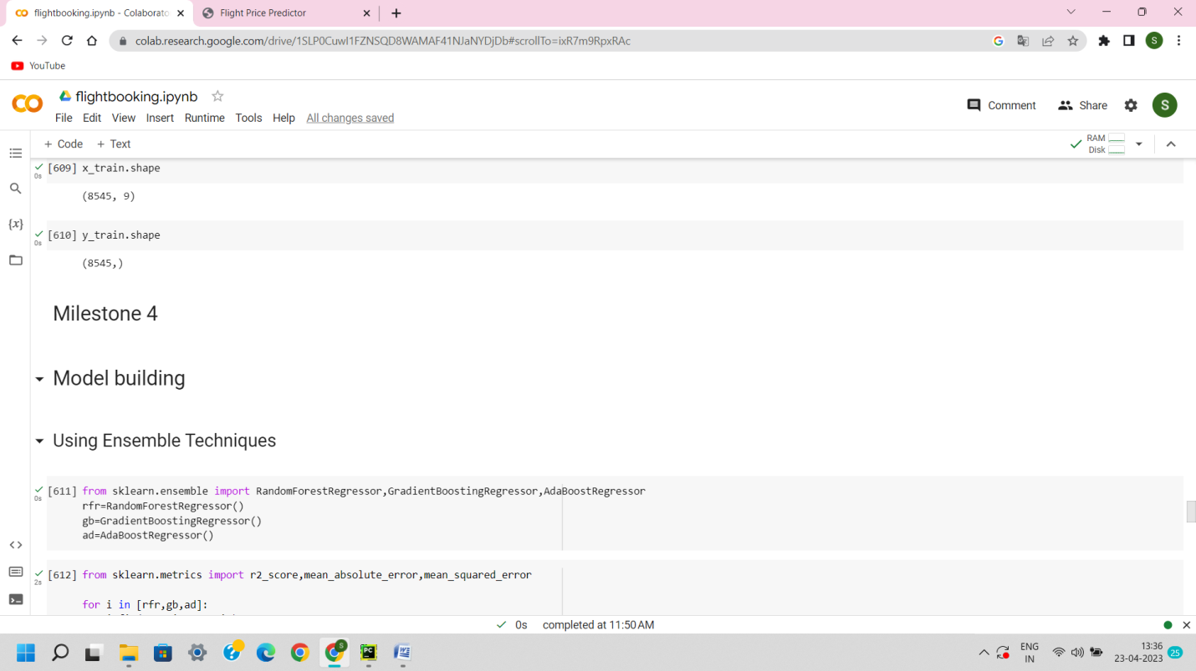

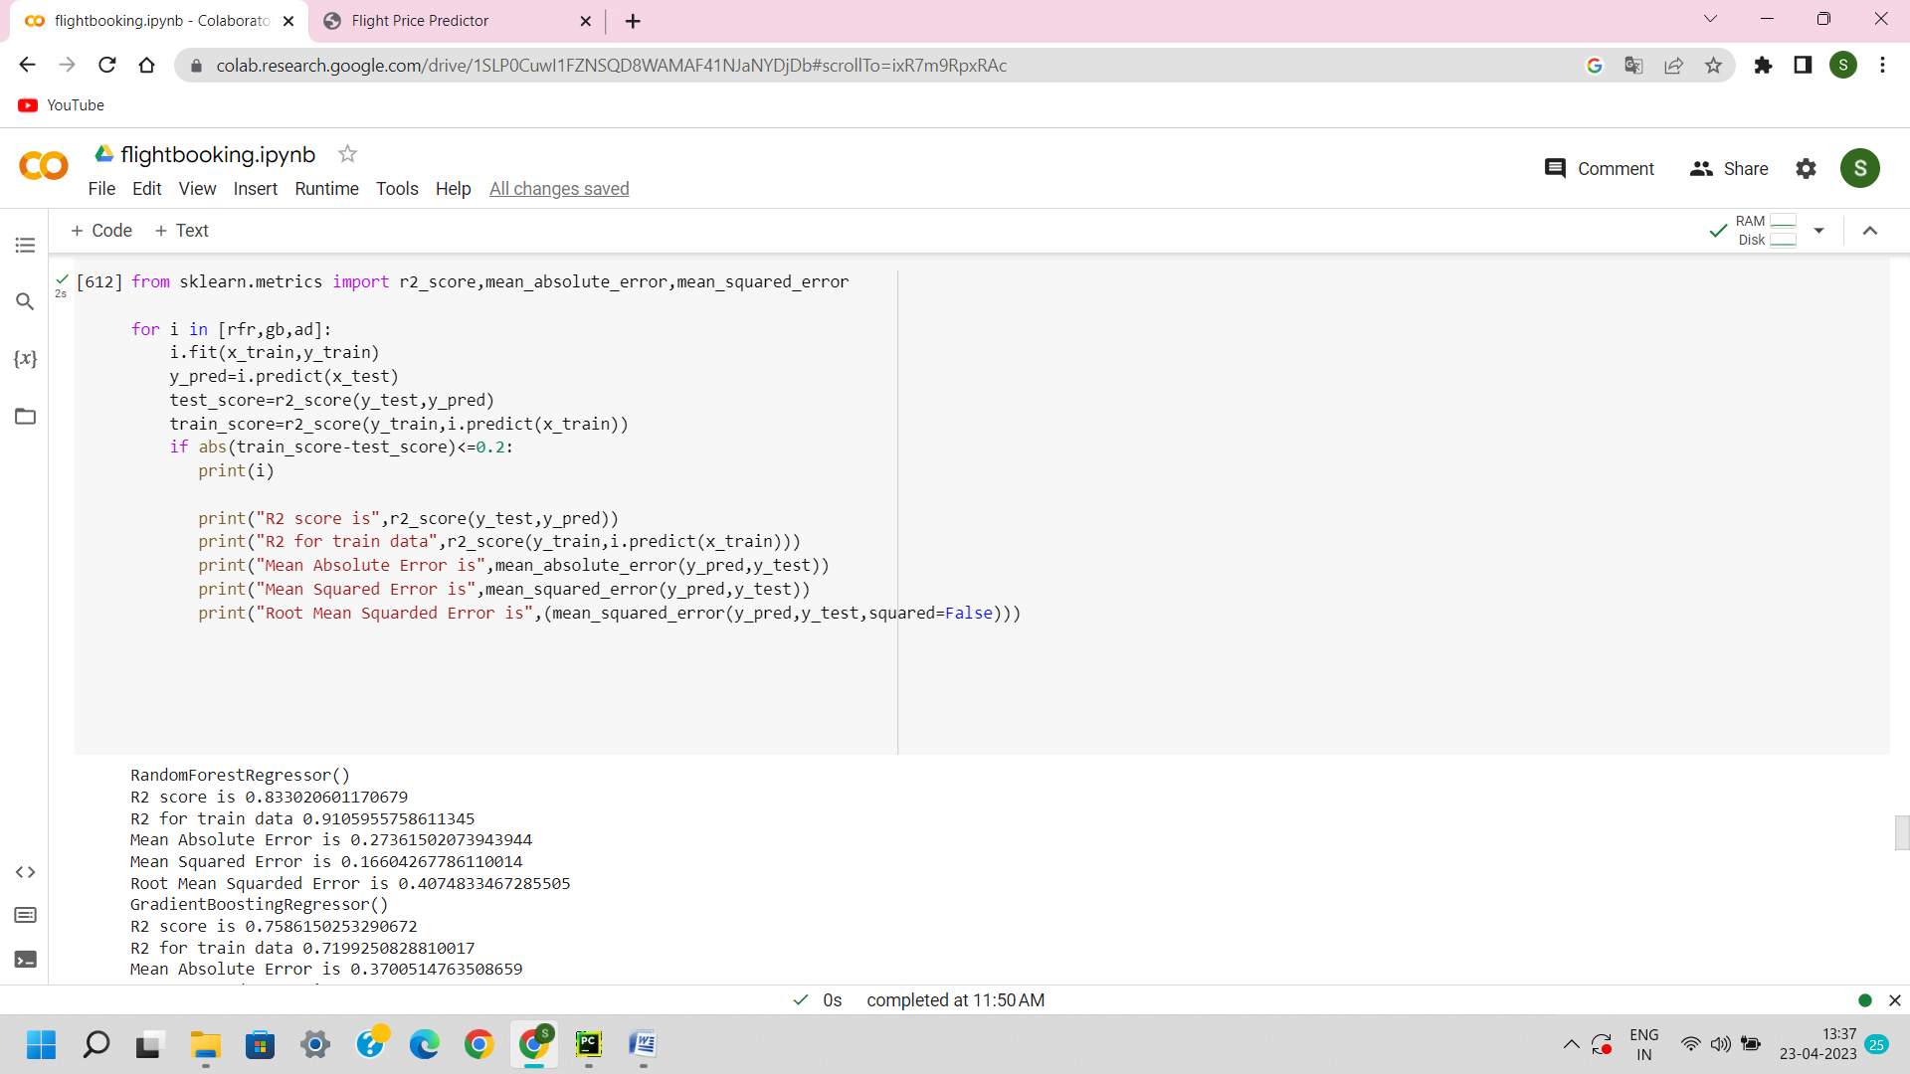

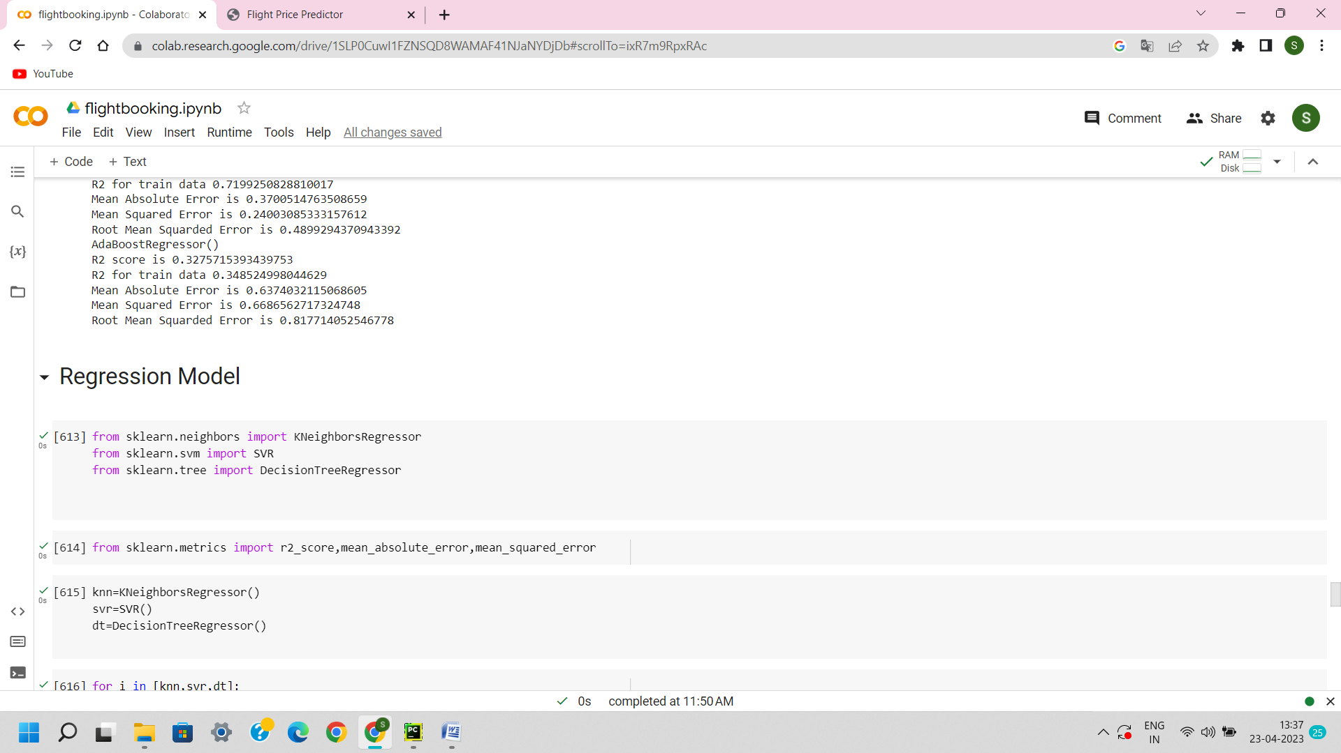

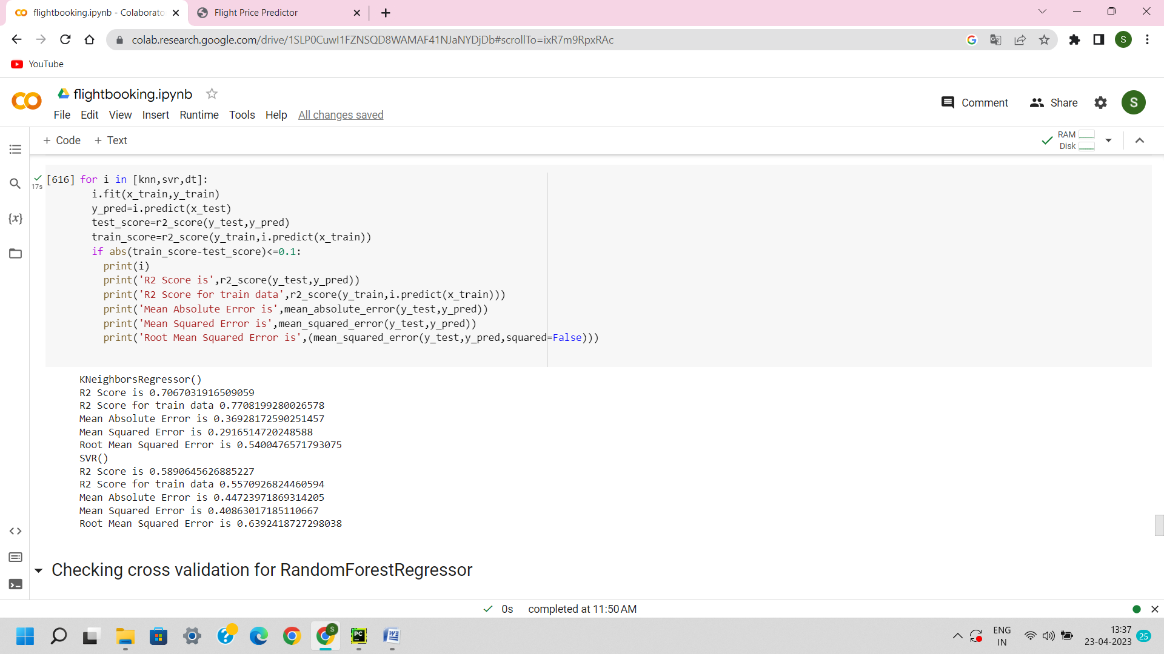

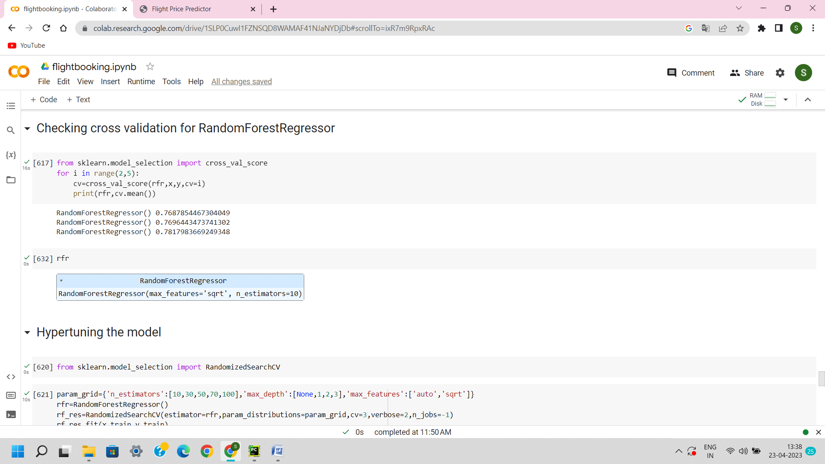

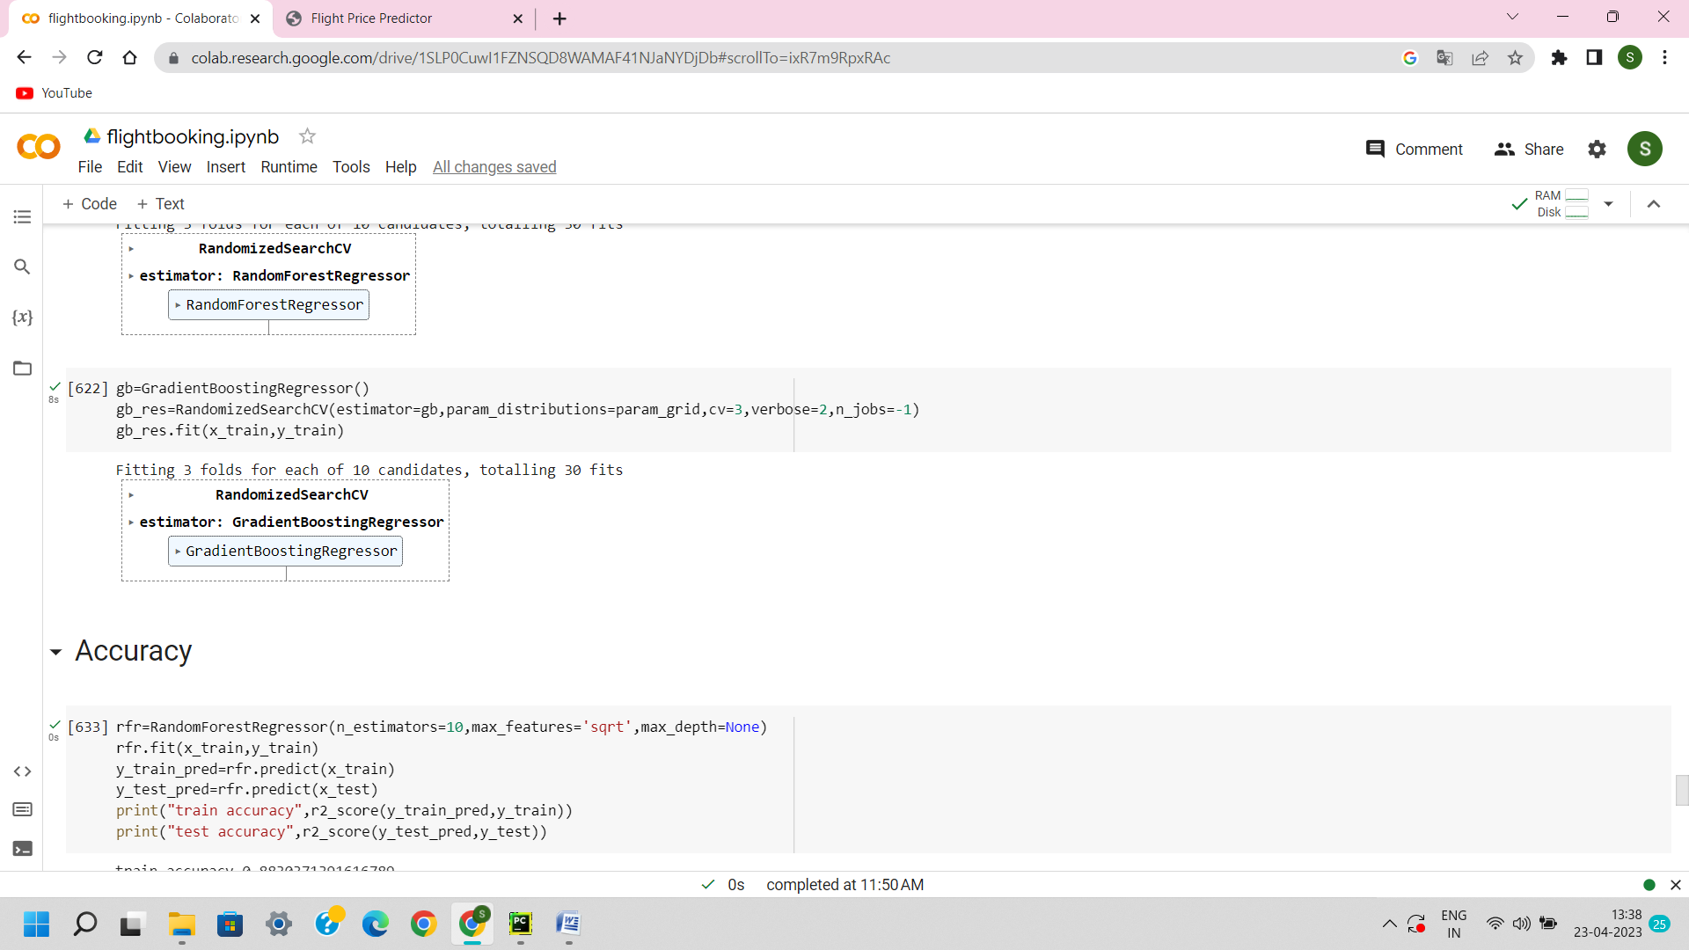

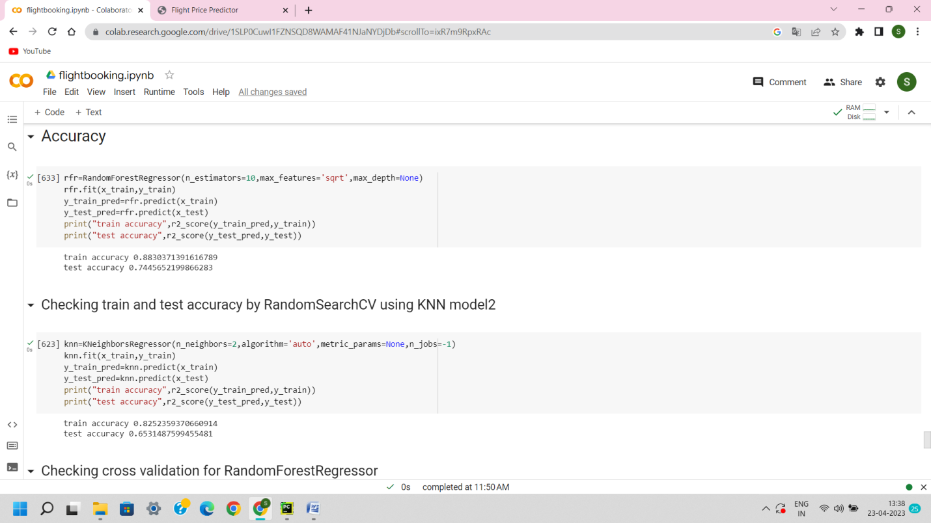

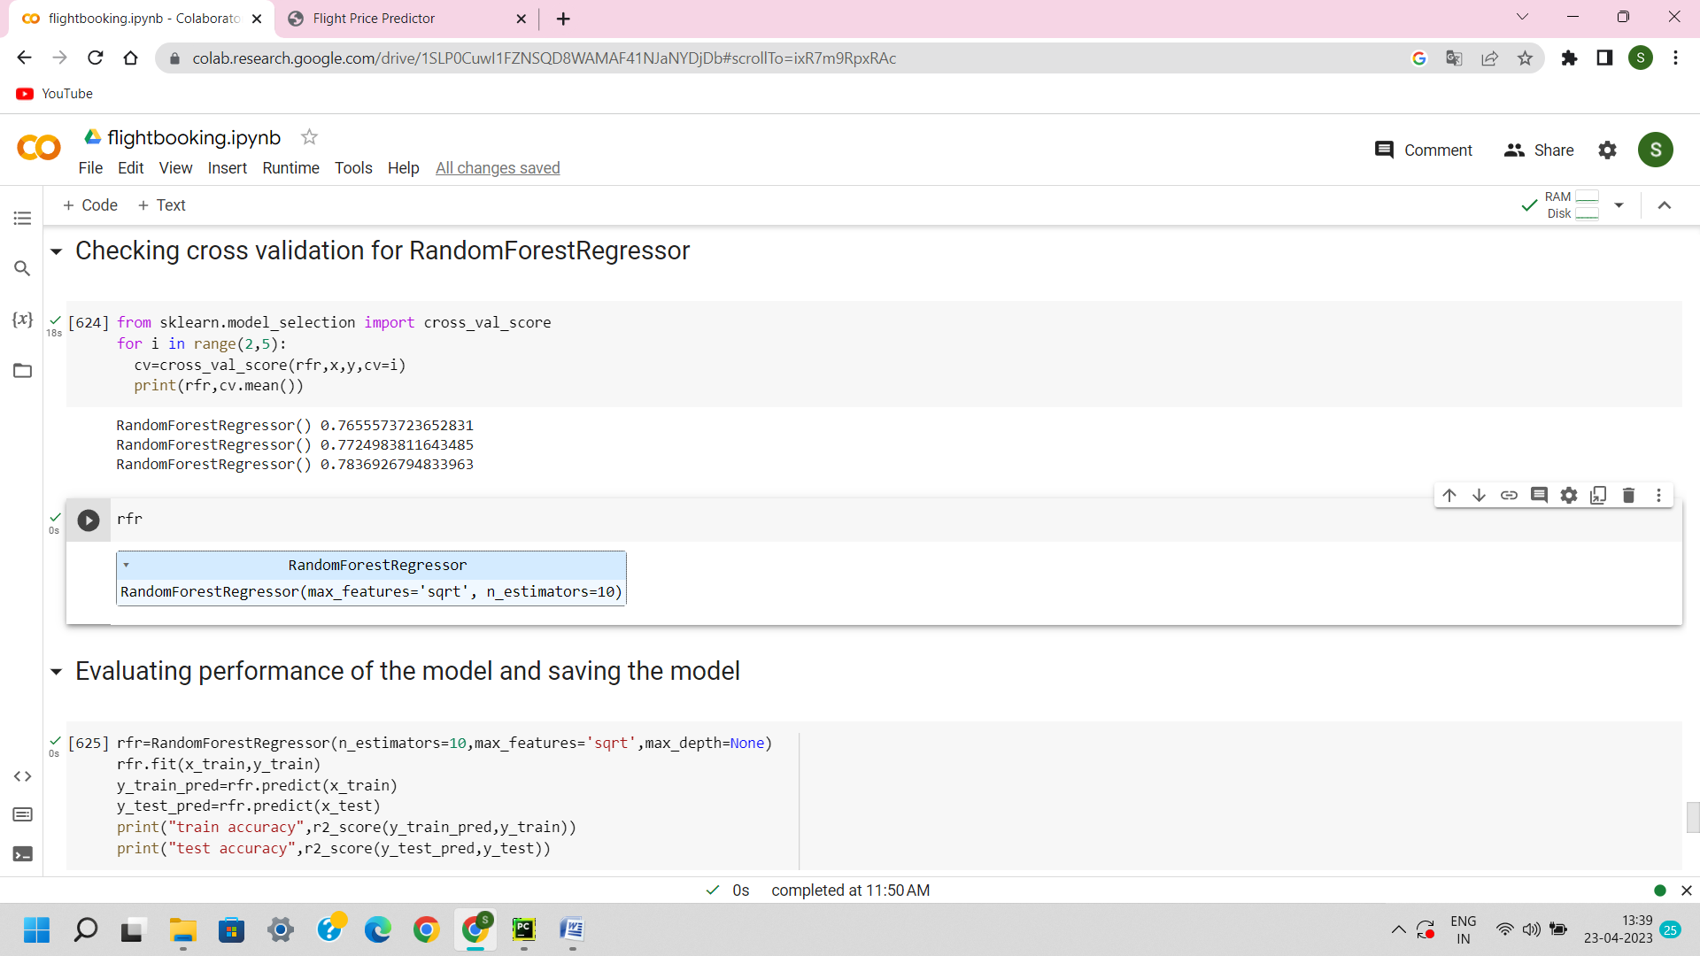

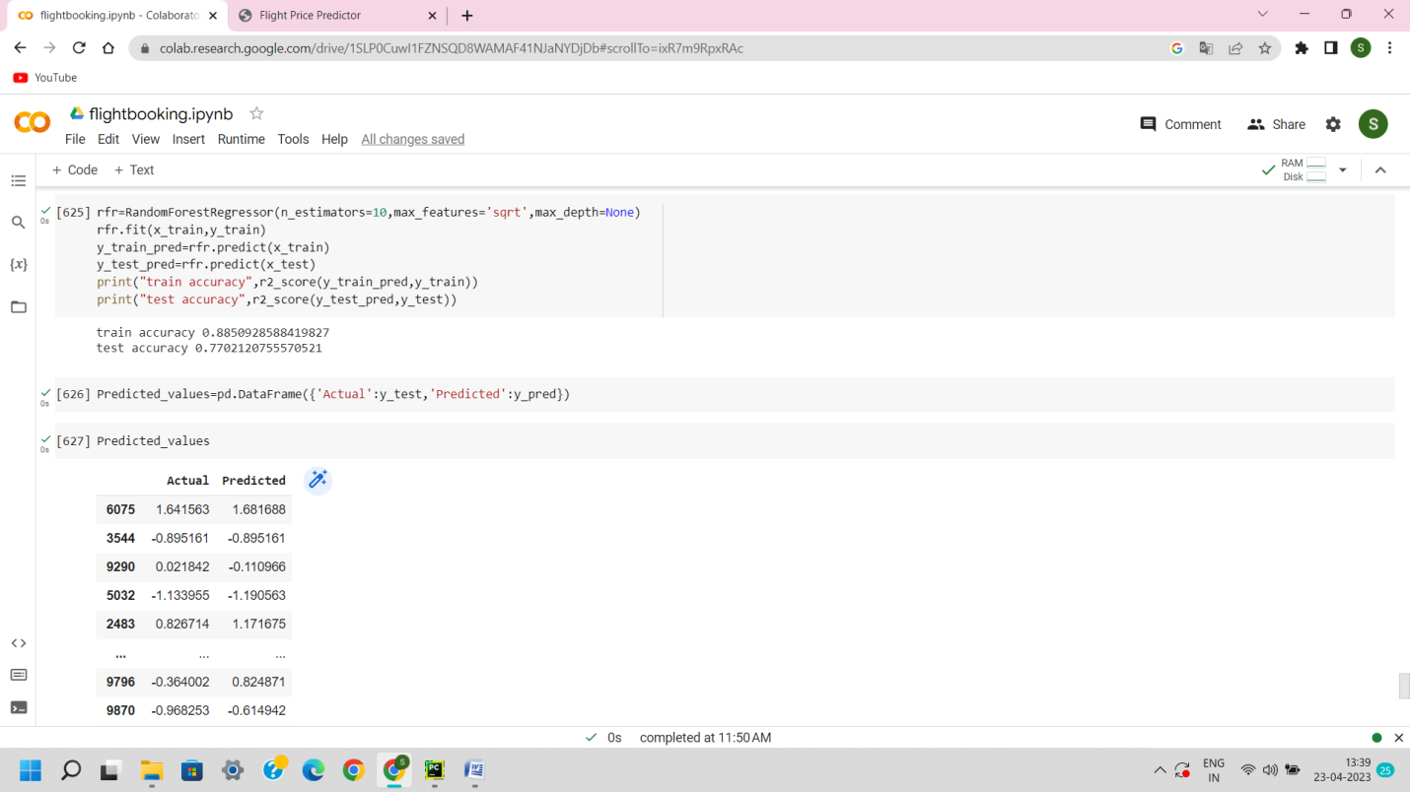

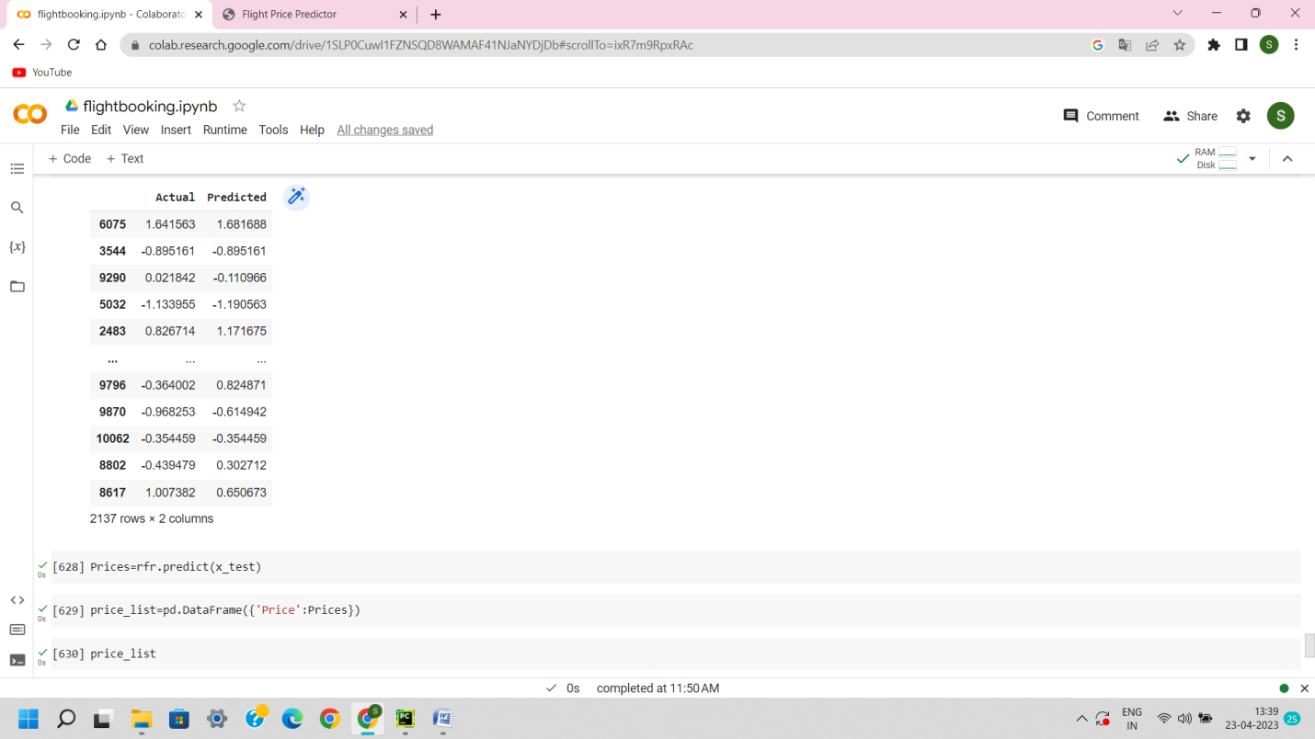

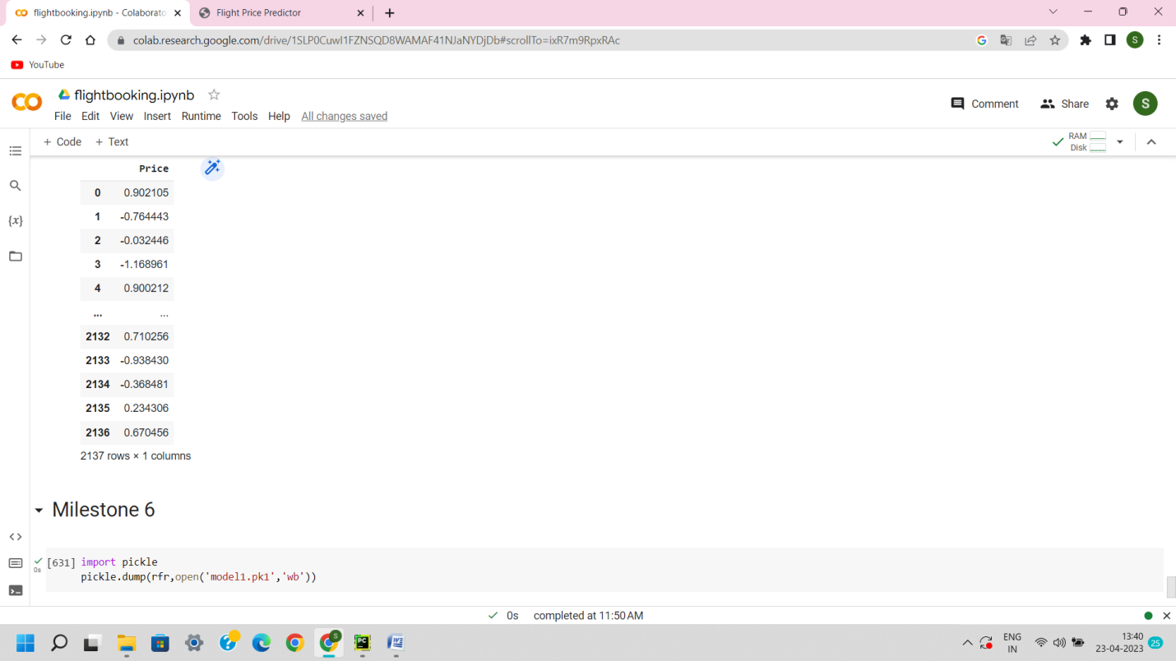

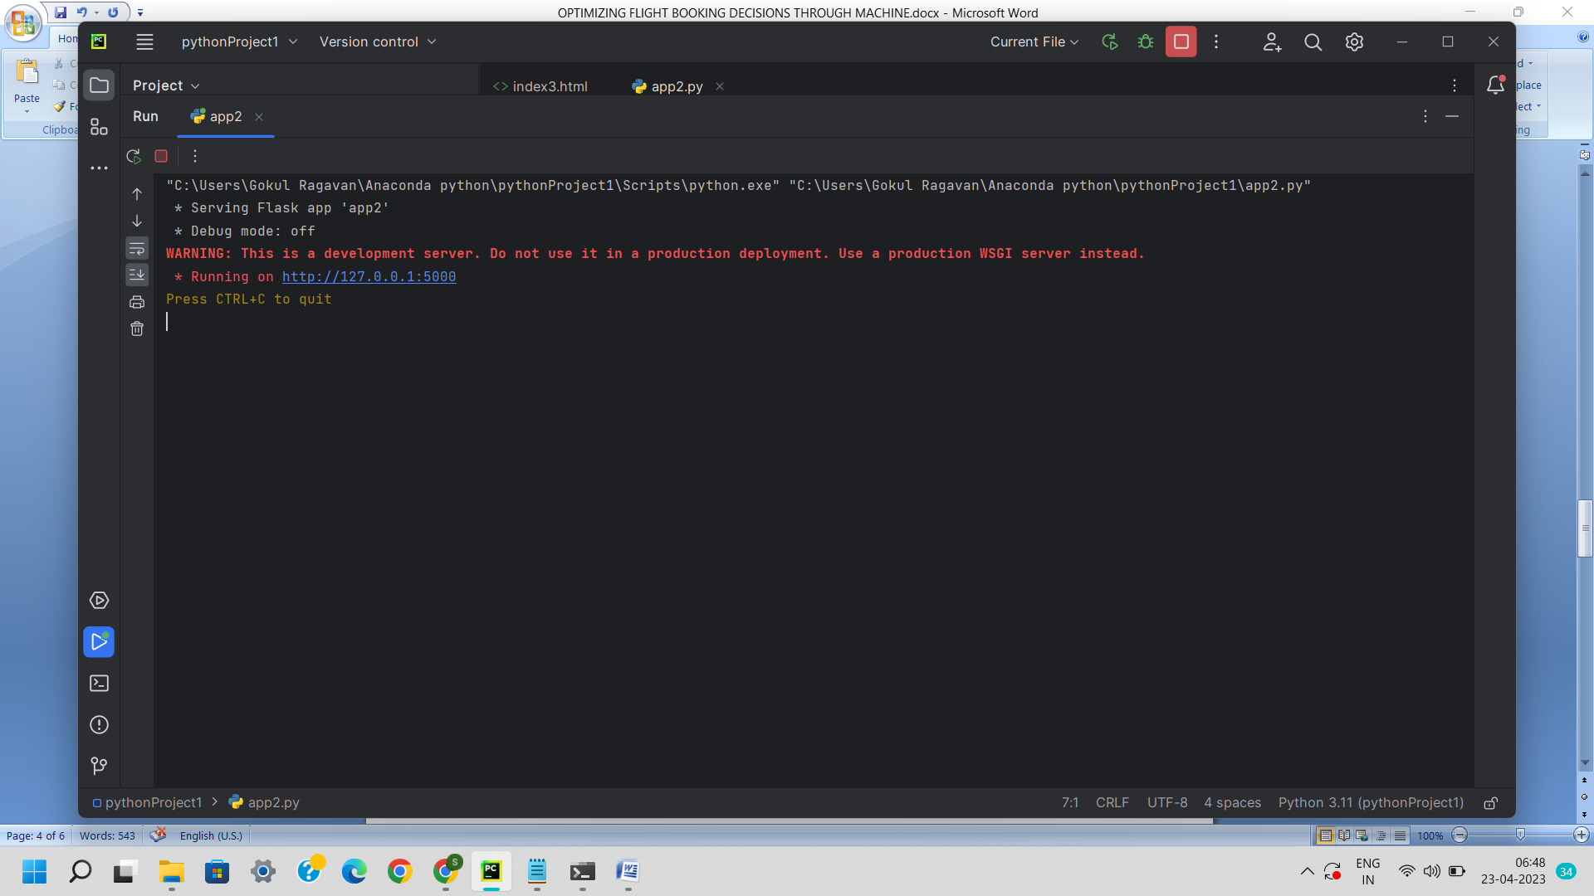

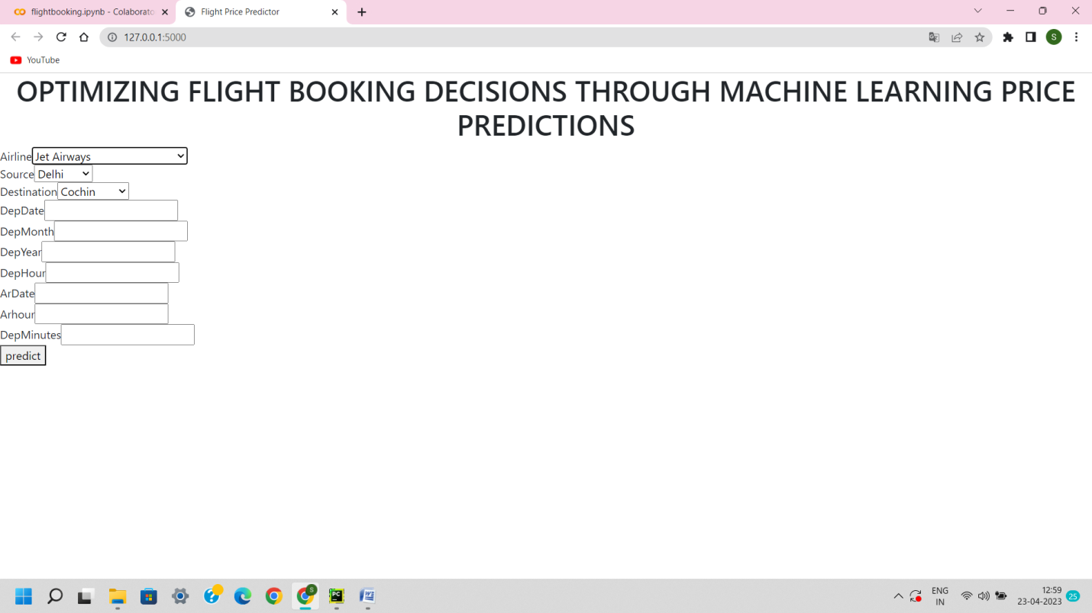

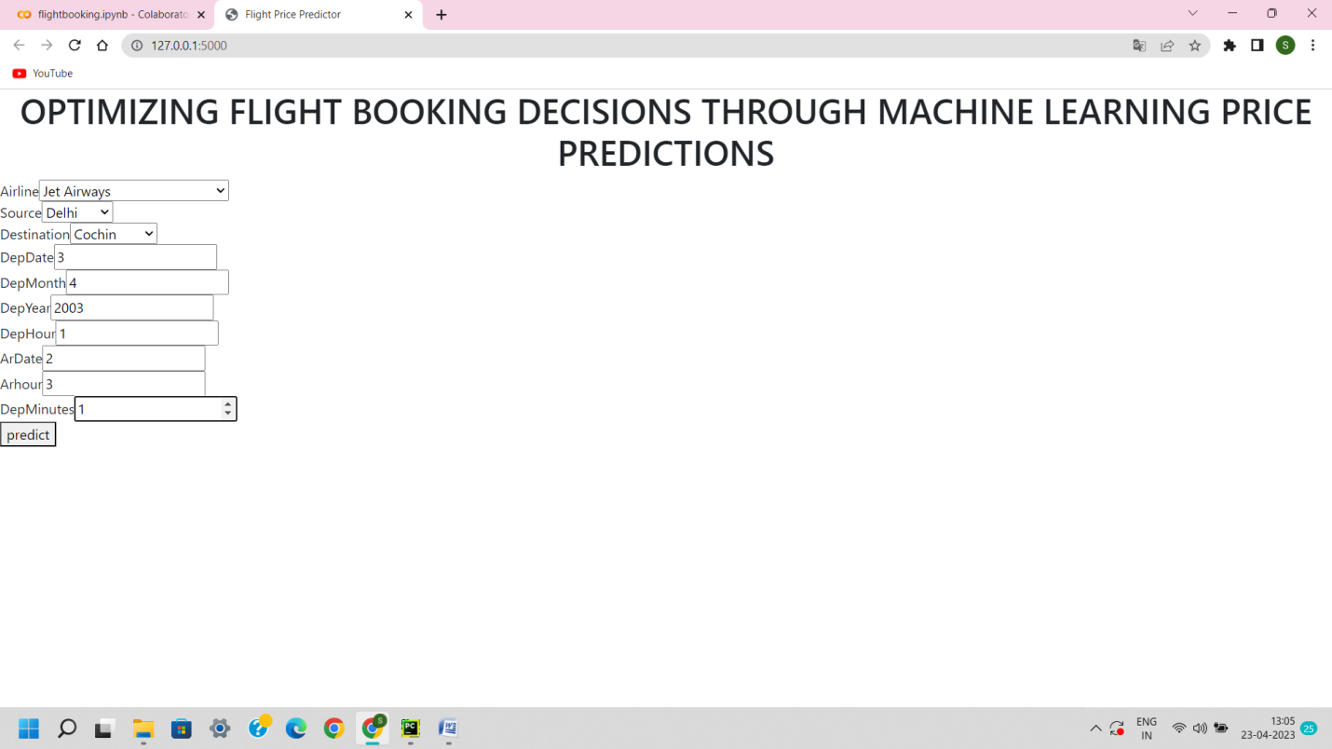

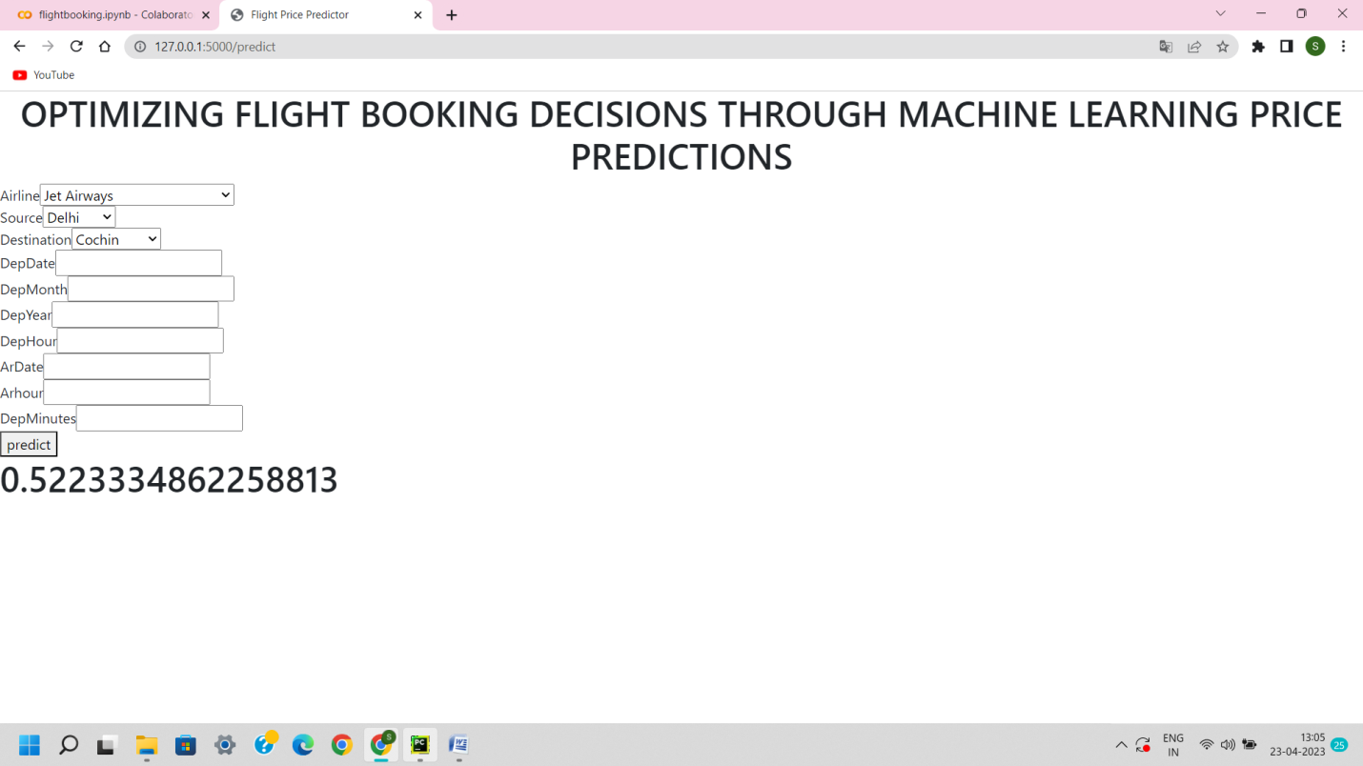

***ADVANTAGES***

* They’re called budget airline for a reason lower rates that make for appealing flight fares for budget travelers.
* First remember these airline serve fewer routes.
* Speaking of routers. The best budget airline fly both national and international routes.
* To take advantages of the promotion make it a habit to always check a booking website for new promo fares and discount packages.

***DISADVANTAGES***

* Many budget airline don’t use major airports for takeoff and landing.
* Beware of hidden charges aide from the original fare advertised on the website.
* Another possible issue you might face with promotional tickets is that dates or destinations may be limited.
* Also the flight status might be delayed as well.

***APPLICATION***

* Fare Arena
* Kayak
* Air India
* IndiGo-Book flight ticket
* Kicoi.com-Book cheap & flights
* Vistara-India’s Best Airline
* Last minute flight Booking
* Expedia.

***CONCLSUION***

* Flight ticket booking app development latest trend in the market as the travel is rising globally, and people are replying app for easy trips. Machine learning algorithms are applied on the dataset to predict the dynamic fare of flight.
* This gives the predicted values of flight fare to get a flight ticket at minimum cost.
* Data is collected from the websites which sell the flight tickets so only limited information can be accessed, The values of R-squared obtained from the algorithm give the accuracy of the model.
* In the future, If more data could be accessed such as the current availability of seats. The predicted results will be more accurate. Finally, We have created the entire process of predicting an airline ticket and given a proof of our prediction based on the previous trends with our prediction.

***FUTURE SCOPE***

* Air ticketing is very dynamic and booming work sphere with great future scope on a global level.
* The Air ticketing industry is one of the largest and most profitable industries in the word and contributes substantially to the foreign exchange earned.

APPENDIX

***SOURCE CODE***

